The Legendary "GK" Commemorative Snare
This unfortunate mischaracterization is one that has been in the public eye for quite some time now. Whomever purchased this snare also purchased a great deal of incorrect data to go with it. This snare has had mentions in Rob Cook's SLINGERLAND book as well as numerous times across the internet over a number of years. None of that actually proves any factual historical authenticity.
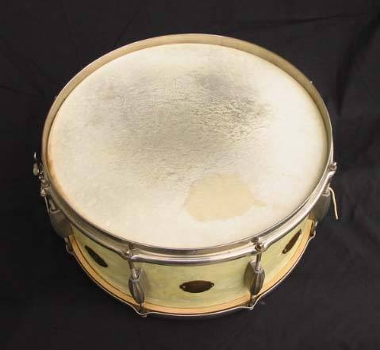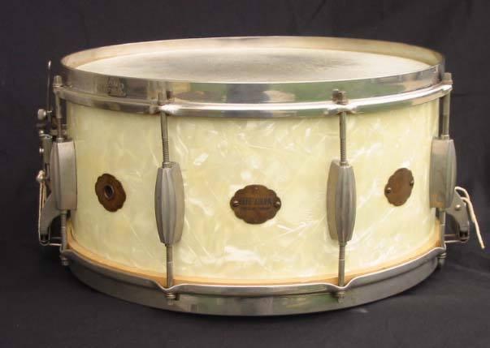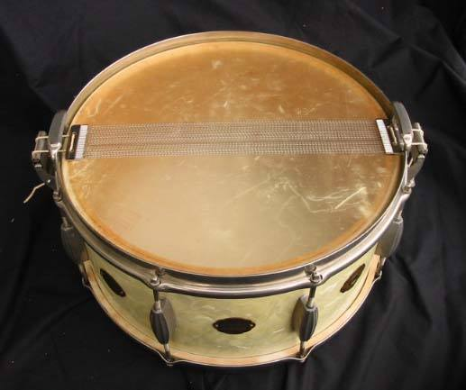
Quite simply, it is not what it is professed to be. Many efforts to find out if these myths had already been debunked were made but to no avail. This author will go under the assumption that the (inaccurate) publicly printed "assessment" of the instrument remains as the prevailing one.
What is sorely lacking in any of the following "history" is any solid PROOF of the statements and claims. To just SAY something is such is not proof on any level. In order to make the point, it is better to see what has been said about it first and go from there. [Author comments on individual inaccuracies as they appear.] Presented below is how the drum was described along with a (Author's opinion, meaningless) "COA":
"History: This drum is a 6.5x14 white marine pearl Slingerland Radio King snare drum... [That much can be agreed upon] built for Gene Krupa. ...[This is pure conjecture and no proof of the statement is ever shown]
The drum dates back to the pre-1938 Radio King era, which coincides closely with the years during which Krupa performed with Benny Goodman (35-38). ...[Another unfounded statement with no proof attached and, in fact, not correct]
Also, this drum’s date of manufacture can be further pinpointed as follows:
- The thumbwheel adjustments on both the strainer side and butt side snare extension brackets were used from the inception of the Radio King snare drum (1936) until 1938, after which the thumbwheel adjustments were discontinued at some point in 1938. [Completely inaccurate. The extension brackets that had the company stamped, brass flat-plate that included the adjuster gears and first model snare gates started with the ill-fated "Broadcaster", not Radio King and were still being installed on Radio King snare drums as late as 1942. Possibly even later than that. Below are photos of a 7 X 14 Black/Gold lacquer "Hollywood Ace" Radio King snare that was purchased new in 1941. The author owned this drum for a number of years and has also seen numerous Radio Kings similarly equipped that were clearly post-1938 models]
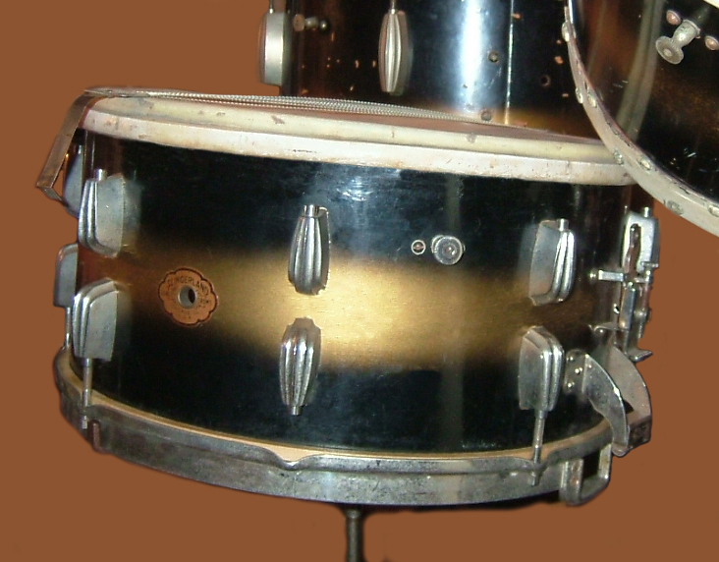 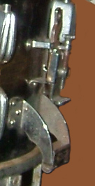 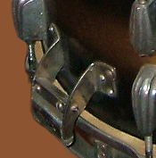 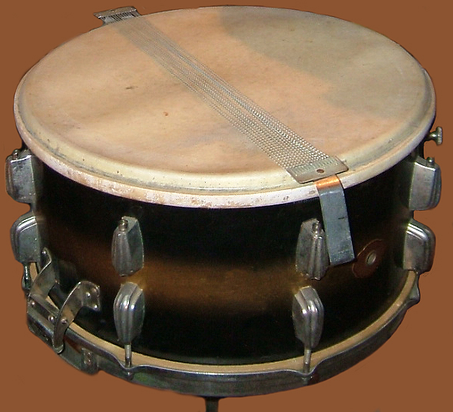
- Radio King snare drums were introduced in 1936, ...[Introduced to the public in 1937 is closer to accurate] but on those first drums the lugs did not utilize threaded inserts. Instead, the tension rods threaded directly into the casting of
the lug itself. This was a poor design because the lugs tended to strip out over time and as a result, this lug was eliminated in the 1937-38 time frame in favor of the lugs with the threaded insert. ...[Although technically correct, none of all that is really relevant to this particular drum]
-This drum has threaded inserts, and as a result, it would have been manufactured no earlier than 1937. ...[Extraneous comment. In fact, not even applicable in this case.]
-Based on the data above, we can say with relative certainty that this drum was built in the period of 1937-1938. [In fact, based on its details, built any time between 1940 and 1952 is more plausible]
-The last two owners of this drum are well known to me, and I assisted in the transaction that resulted in the sale to the most recent owner, so I am very familiar with the drum. In fact, the most recent owner is a very prominent collector and long time customer of mine. Although there is no definitive documentation to track ownership and usage of this drum directly to Krupa, ... [This is the point where he should have stopped] the drum is designed in a manner that Slingerland utilized only for special drums built for Krupa, who was their premier endorsement artist...[Pure guess-work. Slingerland did nothing particularly 'special' for any of Gene's drums and, again, where is the proof?]
-Key identifying features include the following:
- In addition to the standard Slingerland vent hole badge this drum has two other badges, both of which were used for Krupa’s special personal drums. ... [More unfounded guessing. Where is any proof of this statement offered?]
-One of these badges is engraved with Krupa’s name and the words “king of swing”. The other badge reads “Slingerland Radio King, Chicago, Illinois”. Slingerland used these two other badges on special drums built for Krupa. .... [More unfounded, unproven fiction. Photographic evidence to support this claim?] In fact, this very drum was used as the drum for illustrating these three badges on page 147 of the second edition of Rob Cook’s book titled “The Slingerland Book”. I personally confirmed this with Rob Cook.
...[With these points comes the most unfortunate bit of mis-information of the entire sales pitch. No other examples of these claims exist to offer viable PROOF of these statements and it is critically important to know that the third badge mentioned carries a design/logo that did not even appear on ANY Slingerland drum, print ad, catalog, etc. until AFTER WW2 ! This "Lightning bolt" logo did not publicily exist any earlier than 1947-'48]
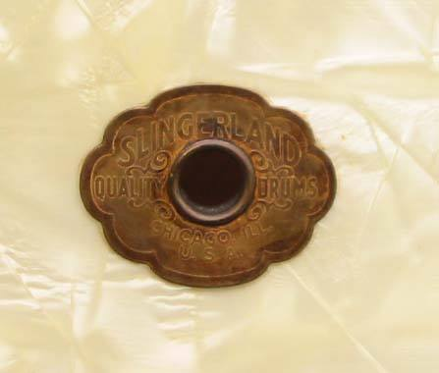 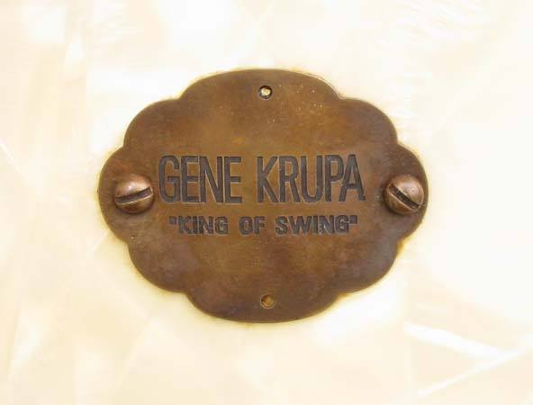 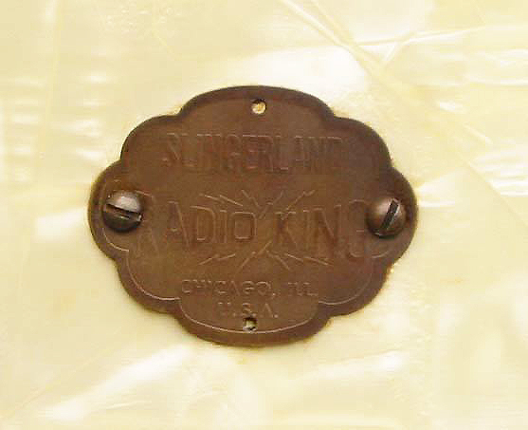
- The interior of the drum was finished with great attention to detail. In contrast to what is normally seen on Radio King shell interiors, the interior of this drum is very smooth and the shell is the nicest Radio King shell we have ever seen. Slingerland paid close attention to the drums they built for Krupa, ...[Again, where is proof of this? Other images to show this to be correct?]
-and this drum is evidence of that commitment. The extra attention to detail also supports the fact that this was a special drum for Gene, perhaps built by Slingerland to commemorate the formation of his own band after leaving Goodman in 1938. [There is nothing here to "support" any of these claims. Pure guessing and not accurate other than, possibly, the 'commemorative' point.]
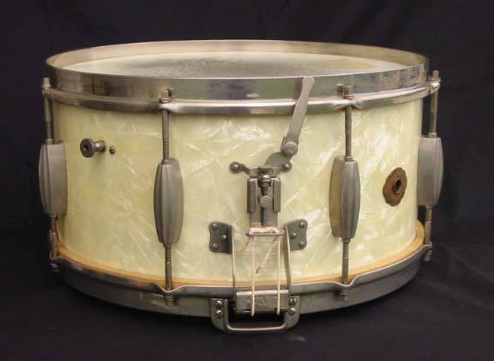 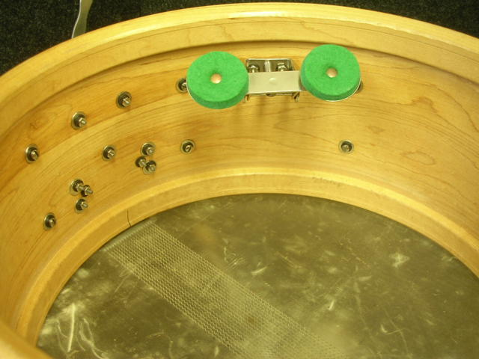
Additional Research:
Dr Carl Wenk is a noted Slingerland expert and has done much research over the years on Slingerland drums. His input is consistent with our findings. Below are excerpts from Carl’s input to us on this item."
"From the construction and features this drum was made no earlier than 1937 and not likely later than 1939. ...[Discussd earlier. Could have been as late as '52.] -Actually I think there is at least a chance that Slingerland made this drum for Gene in celebration of the occasion of him forming his own band in 1938 after leaving Benny Goodman earlier that year. Gene already had plenty of Radio Kings at the time this drum was made circa 1938, including many in this model, which had been the flagship Gene Krupa Radio King signature Slingerland snare drum since 1936. ...[In fact, this was actually not the so-called "Krupa Model" snare. Firstly, that was a model only offered in chrome plating for the first year (1937) and was equipped with four bolt extension brackets, not six. Although the six bolt brackets were used as early as '38-'39 edition, they only appeared on a few models. The "Ray McKinley" and "Ben Pollack" models, for example. In fact, during the period deliniated by this person, never on the Krupa model as far as the catalog images were concerned.
[Below] The very first catalog (again, started in late 1936 but serving '37 by the time it would have been published and distributed) showing the first image of the "Gene Krupa Model" Radio King snare drum.
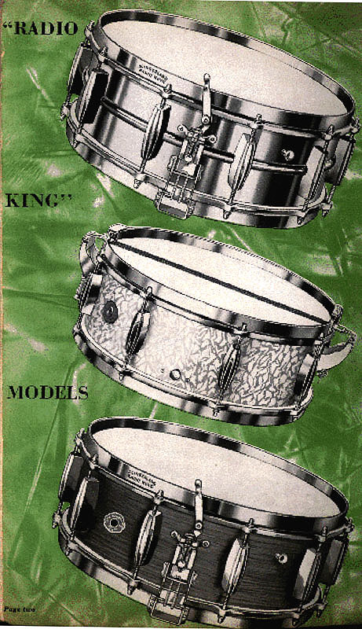 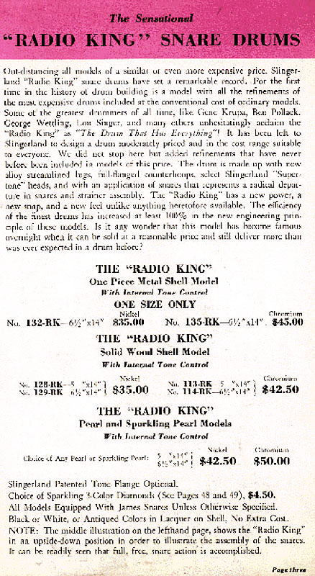 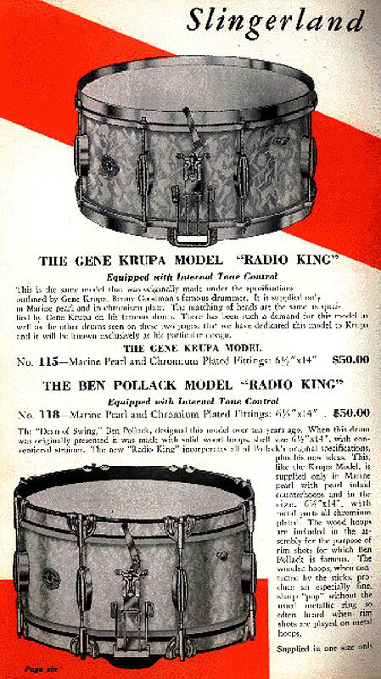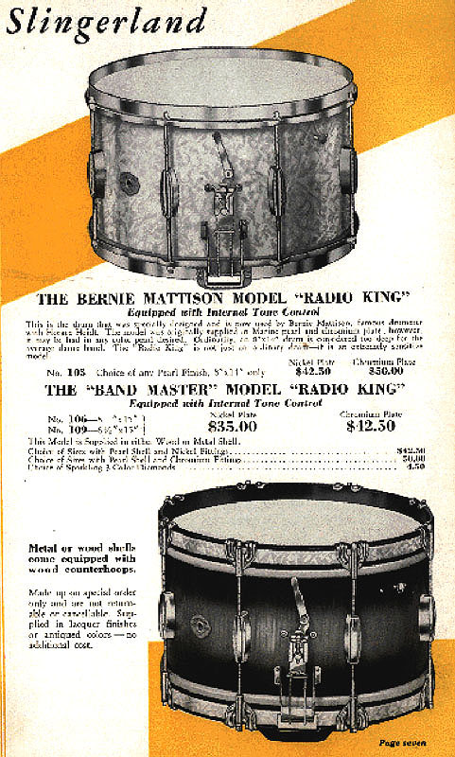
Note also that, like the snare Gene proudly holds under his arm in the original Palomar photo shoot, ALL models still show the (Broadcaster) Todd-1 Tone control illustrations. An unfortunate forgotten 'detail' when Slingerland had to quickly change designations/artwork from 'Broadcaster' to 'Radio King'. BELOW, the next edition, '38-'39. Clearly, the 'Marine Pearl' background (instead of 'Sea Green Pearl') reflects Gene's preferences.
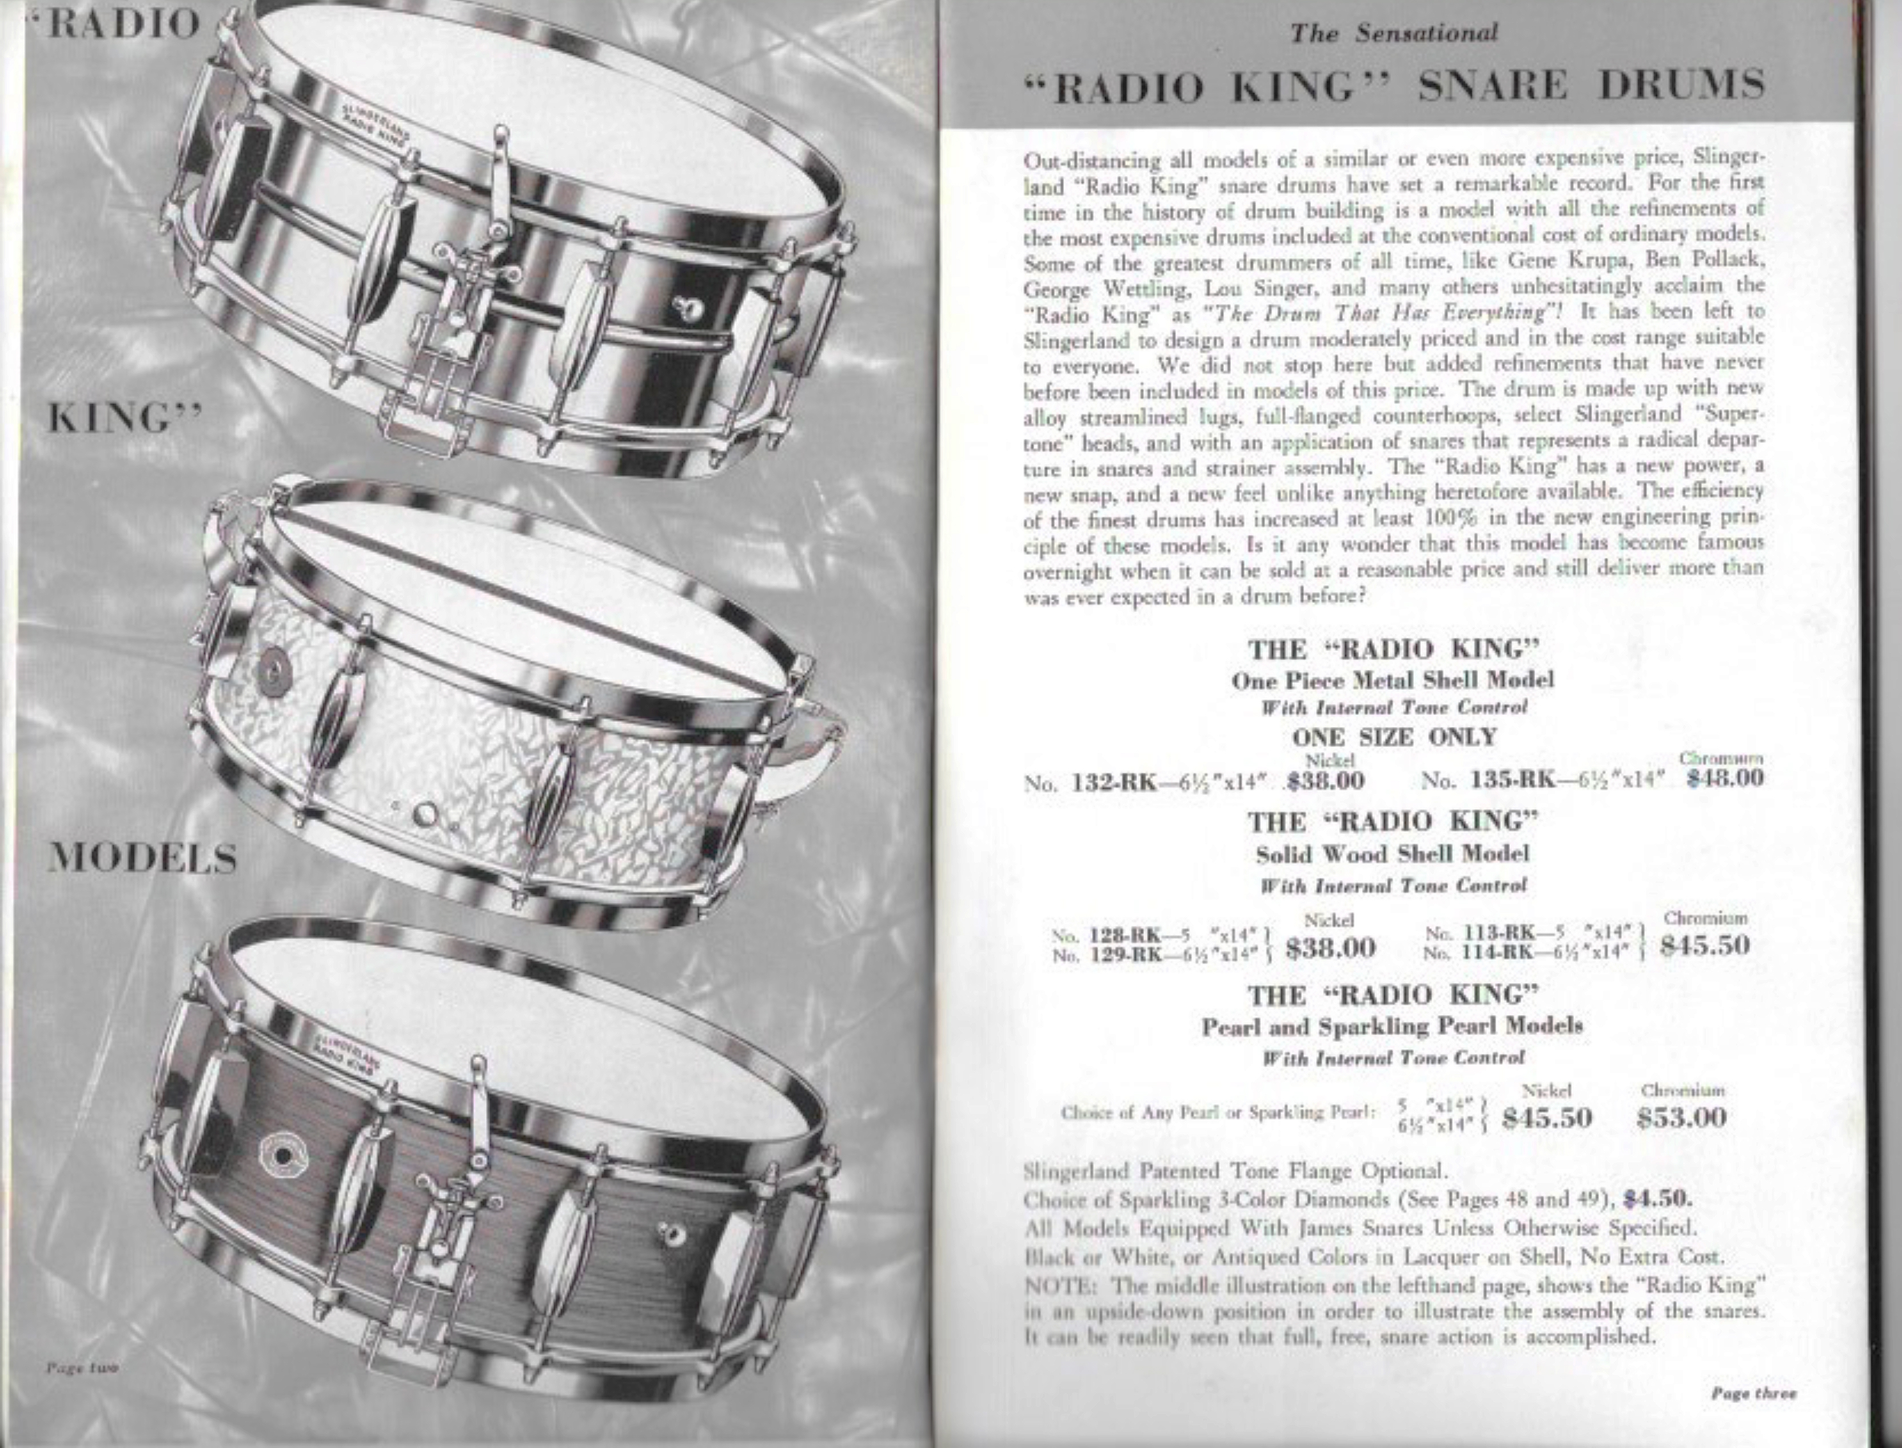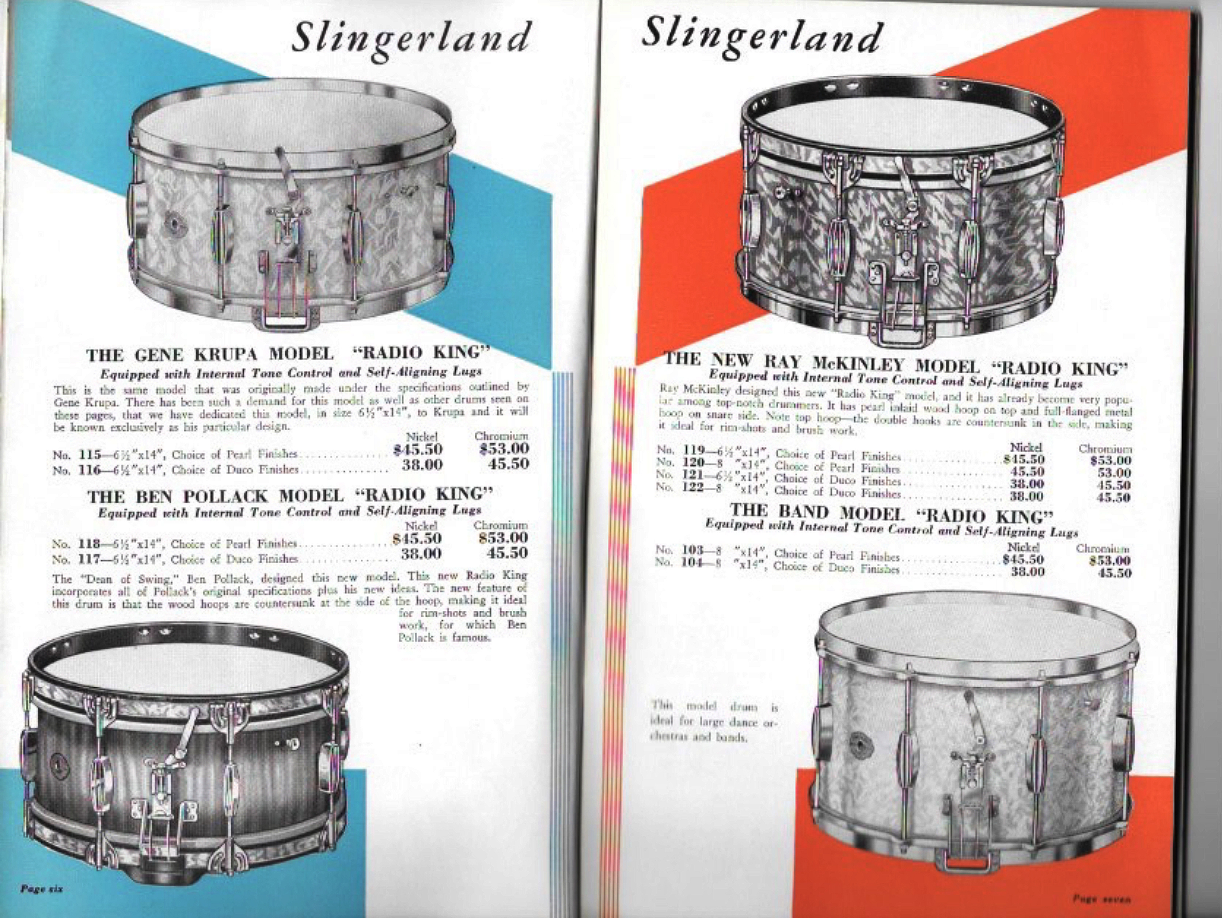
Also, the first evidence of six bolt extensions. The "GK" model retains the same four bolt version. Important changes in that previous '38-'39 edition, however, were the added mention of the new "self aligning lugs" as well as inclusion of nickel plating and lacquer finishes. All these improvements carried over into the next '39-'40 edition (shown below from both the Brown or Silver cover version) and became 'standard'. The only addition to that year was adding 7 and 8 inch depth shells. The model #115 remained, however, at 6.5 X 14 and the catalog showed the identical image as preceding years. If the "GK" model had changed to six bolt brackets, there is no evidence of that shown anywhere until the images of the (GK) 1-N set in the post War, '47 catalog. It's likely that the change to six bolt brackets occurred during the War-time 'gap' that brought on so many other changes as well.
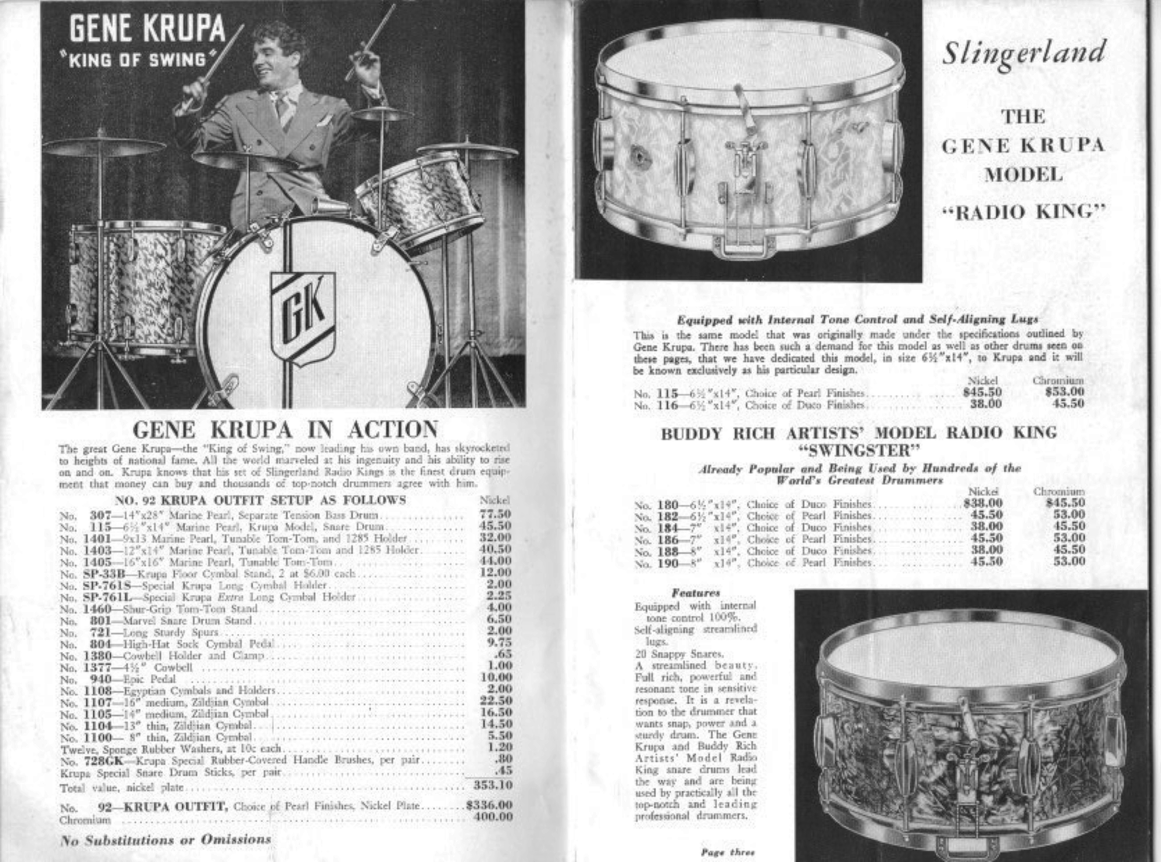 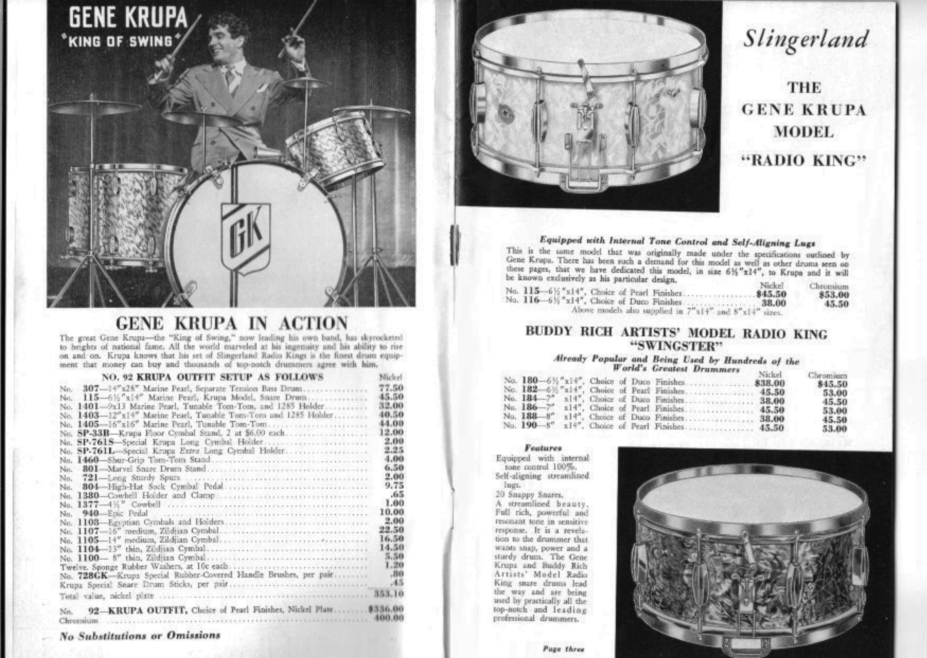
1939-'40 Brown cover 1939-'40 Siiver cover
For the first three to four years of the "Gene Krupa Model" Radio King's existence, it remained as a 6.5 X 14, solid maple shell, 'Marine Pearl' covered snare designated as #115. By 1940, it had been joined by different depths with added part numbers. In the '40-'41 catalog [Below, Left] more depth options and part numbers were added. By the time the last pre-War [Below center], part numbers had been shifted around considerably. Models like the "Ben Pollack" model were then a thing of the past. Nowhere during this span of time in the catalogs does it show a "Krupa" model snare with six bolt snare extension brackets. (green) supplemental catalog emerged as the '41-'42/'44-'46 edition

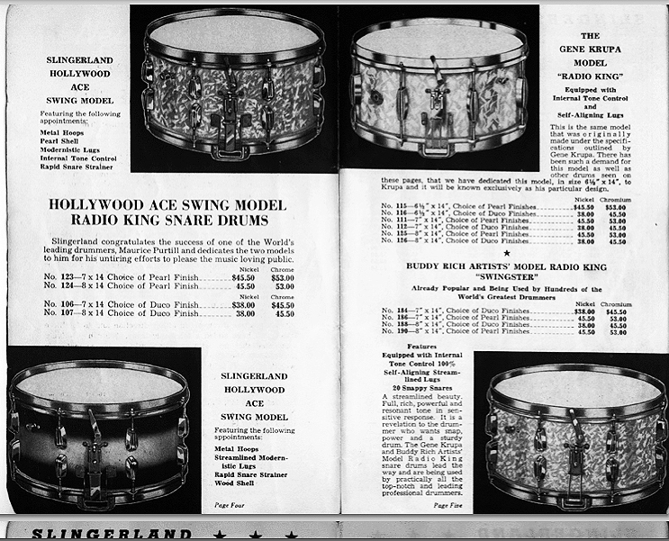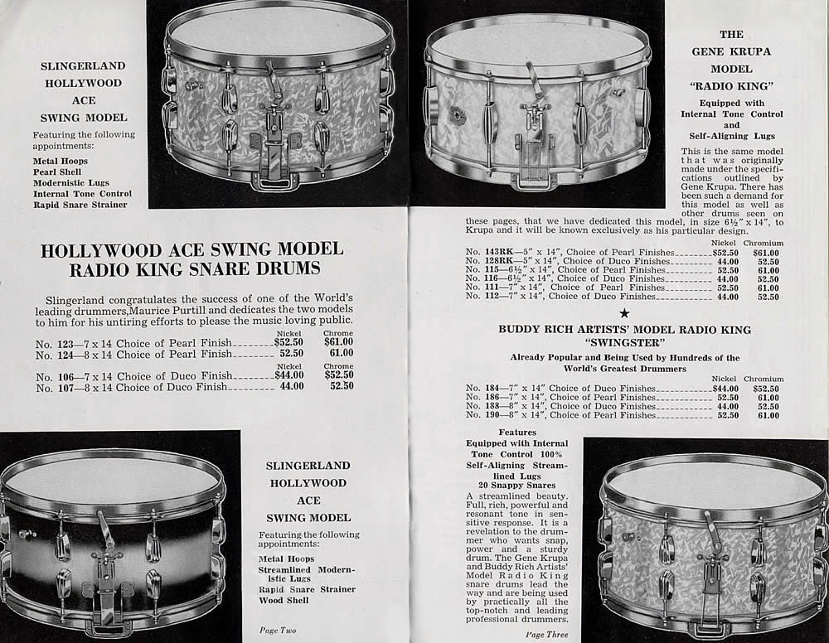 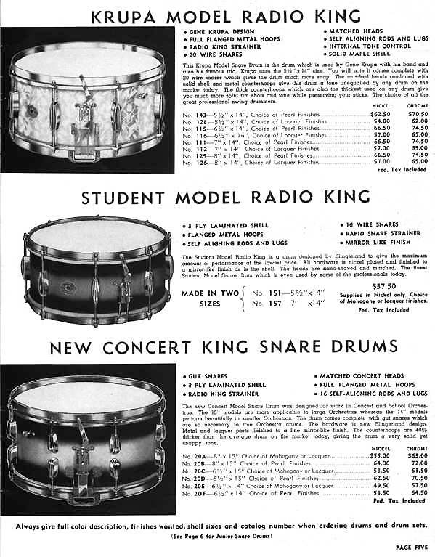
That does not happen until the '47 catalog and only in the image for the 1-N set with a 5.5 snare. Which further supports the assertion that, considering what is stamped on the extra badges, this one was probably built closer to '47-'48. In fact, even the '47 through '51 catalogs have the same 'GK' model image with four bolt extension brackets. By then, of course, in reality, they were long gone too. There is no accurate date of when exactly the four bolt extension brackets were phased out but it is safe to say that, by the time this drum was likely to have been built. they were already obsolete. The whole point being that there is no documented proof to indicate exactly what this snare was or exactly when it was made and why. It is clearly much later than '37-'38, however.
Also, as far as being historically accurate, Gene removed the four bolt extension brackets very soon after they were introduced, and is not shown playing any that had the brackets in place until '45-'46 and it was a 5.5. By 1939-'40 he had already permanently changed to the 5.5 X 14 model [No brackets] for the full band set-up. He had already been using a solid maple 5 X 14 with the small group sets as early as 1936. Covered (with photos!) in the Snare drum section of the book.] Photos Below,(L to R) '37, '38 and '39. Actually, two different snares (with different bottom rims). No extension brackets to be seen on either.
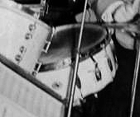 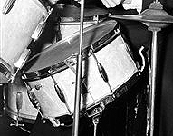 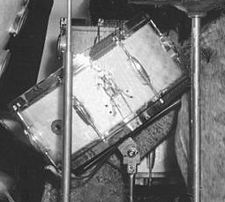
As also previously discussed, the bottom rim snare gates of the style on this commemorative drum were still in use as late as the early '40's. Perhaps even after that. Although the flatter more rectangular style gates appeared first in the '40-'41 catalog, they were exclusively used on the "Super" (sixteen lug, #976 Throw-off) models, at first. Eventually, they became 'standard'.
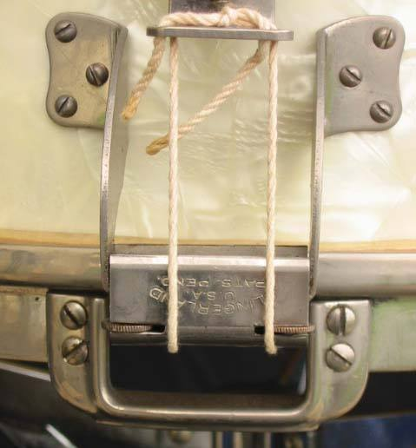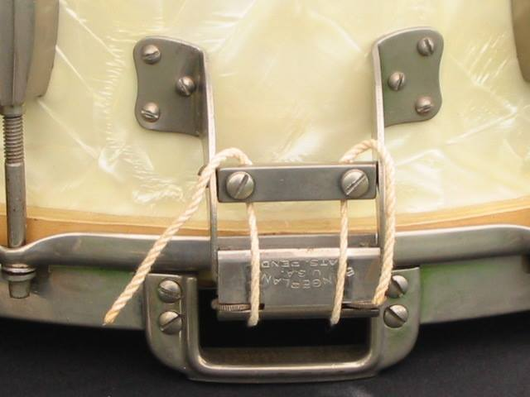
(Below-L) shows the Todd-2 Tone control system. On (Below-R) it's important to note that the earliest top rims were still being hand engraved. After that the rims were machine stamped. This one is stamped. 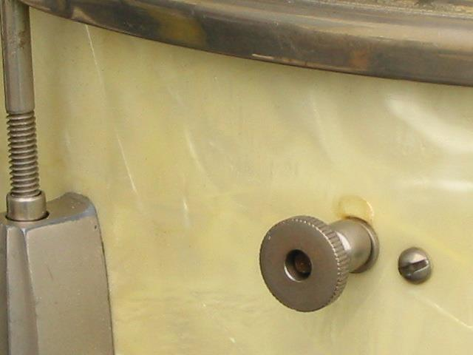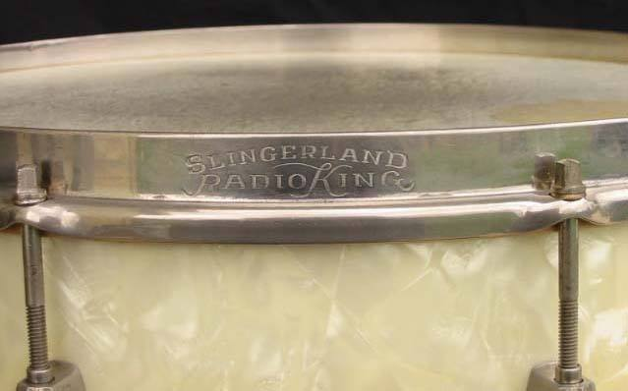
Mr. Krupa was not one to ask for lots of new drums from Slingerland, it was simply not his style. On the contrary, he was well known for keeping his drums going for a long time, making repairs until the road simply wore them out. Krupa also tended to get a bit attached to particular drums. In fact Slingerland often would ask him to
please take some new drums because they did not want people to see Slingerland drums with so much road wear. ...[Although these statements 'hinge' on being accurate, they are still only guess-work. This person presents no proof that he would have any way of knowing what he claims so the validity of these statements is suspect at best.]
-So the fact that this particular drum is so clearly adorned with the name plate, extra badge and non-standard location of the tone control and primary badge would really point to some special occasion. ...[It is nearly impossible to determine what any "Standard" would be. The Badge/Throw-Off/Tone control configurations were in no way "standardized" and several different ones are shown on Gene's snares alone]
-This drum was special, it wasn't just another player for Krupa. Typically Krupa's player drums were right out of the catalog. [True for later in his career but not the case early on. Quite the contrary, in fact...as in, 'no special treatment']
The two-pad tone control, [The fact is that, until the 1950's, Gene quickly removed these from all of his drums], six-hole Radio King brackets and routed lip in the reinforcing rings puts the drum past 1936. The green felt on the tone control was mostly used earlier than 1940. [Also incorrect. Several colors were used until the eventual black felt pad models emerged in the late 1940's. Red, Green and Yellow as well as combinations of all three].
-All the other features are consistent with late 1930s. The cloud badges with Radio King on them were mostly used by Slingerland on practice pads, on cases and for adornment. Slingerland often reversed this badge to make an engraved nameplate for an endorsee, such as looks to be the case here. ...[What other examples of this? He offers no proof. Are there photos extant of any?] Krupa took care of his equipment, but even so it does not appear this drum has seen a lot of road time....[Of little relevance here] ...Carl ---Other Features:
"All hardware is nickel plated. The three point snare strainer and butt plate are the period-correct,... ["Period Correct"....for what period?] original pieces complete with the “thumbwheel” adjusters on both the strainer and butt side extension brackets. The snare strainer is the correct version for the period. The internal muffler is the correct version for the period. Tension rods are all original and correct. Double flanged rims are all original and correct, with the appropriate “Slingerland Radio King” engraving [Stamped...not engraved] on the top rim. Bottom calf head may or may not be the original. Top calf head is a replacement. Snare wires are replacements. The overall condition of this drum is truly excellent. The white marine pearl covering is fully intact and the color has “mellowed” pleasantly. The nickel hardware has taken on the patina that is common for nickel plating from this era. All parts work smoothly and the drum sounds wonderful. We have done nothing to this drum other than to remove the top head for the photos of the interior.
Statement of Authenticity: ...[Sorely lacking in much "authenticity" at all really, other than the fact that it's a WMP Radio King snare drum with two extra badges on it] - Our opinion is that this drum is authentic and was built for Gene Krupa by Slingerland between 1937-1938. Based on this range of dates it is at least a possibility that this drum was used by Gene with Goodman. ...[With all this incorrect data, not possible] While it may not be possible to absolutely determine this fact, ...[Indeed] it is certainly possible that this was the case since the drum was built during the time that Krupa was featured with Goodman. It is also possible that the drum was built for Gene by Slingerland to commemorate the formation of his own band in 1938 just after leaving Benny Goodman." ...[Factual evidence deems otherwise]
In conclusion, it's a very high probability that this drum had little to do with Gene directly and perhaps one he never even saw, let alone played.
© Brooks Tegler

