The DEFINITELY NOT's...
"Once Bitten, Twice Shy..."
In a world where even prescription medications have to be inspected thoroughly to assure sick patients that they are 'real' and authentic (because people's very lives are on the line every day but huge profits can made by the scumbags perpetrating such a crime of making/distributing bogus drugs!), carrying a banner for a cause like whether a drum set/part or cymbal was really Gene's or not, may come across to many as pretty damned frivolous. Fair enough.
That said, it strikes this author as important enough to, at least, point it out. Nearly 40 years ago, as an inexperienced but devoted GK disciple and neophyte collector, he too was stung by this very issue and has never forgotten the importance of the lesson learned. So he forges ahead.
Again, it's important to stress that this section is all about historical accuracy and factual data. It is not here to serve any other purpose.
There have been many lies, half-truths and a wealth of just plain old misinformation perpetrated in Gene's name throughout his lfe and career and even more so long after he was gone (especially in regards to what he used). Gene paid a dear price for that kind of thing from the very beginning and continued to have to 'pay' over and over throughout his entire career. Those who are dedicated to a factual understanding of this man know this well. Those who are not interested enough to seek proof, are happy to parrot the misinformation freely. Nowhere does this show itself more than when it has to do with Gene's equipment! Certainly not a 'new' thing as far as how people record history. Sadly, as is usually the case, tell a lie often and loudly enough and, for those not interested in questioning its validity, it becomes, for them, 'truth'. Once armed with this fragile 'truth', they are ready to 'defend it to the death' if they think it necessary. Clearly, the main reason for this is that they would rather do that than actually admit to their own gullibility. Especially when it involves forking over untold amounts of money for a "treasure" that is, in fact, junk.
This author was once a victim of one of these very scams. Like so many others, he was so anxious to get a 'real', tangible piece of his idol's history that he willingly believed what was said about the items presented to him. Luckily, however, logic prevailed within a year of paying a lot of money and a simple 'test' proved that he had been duped.
Being an avid (some might even say 'rabid') collector of ANYTHING 'Gene' and Slingerland, be they Radio Kings or Sound Kings, the revelations about being taken advantage of were very quickly softened and tempered by the fact that the drums were, regardless of their true history, still nice Radio Kings and a good addition to the collection. With the benefit of 30 plus years' experience, there would have been some blatantly obvious inaccuracies seen. In an effort to pass along this author's experience in the "If I had only known THEN what I know NOW!" category and perhaps save someone else the embarrassment of being "had", this author offers all the sordid details below.
The set was a typical group of four drums presented (14 X 24, 16 X 16, 9 X 13 and 5.5 X 14 snare) as an "Original Gene Krupa drum set". In 1982, the phone call came in and the author was offered the whole set by a vintage drum dealer in Connecticut. The dealer had (as he always was with nearly every one of his 'customers') already become a friend as well. The description of the drums that made up the set were offered with the same (innocent) excitement by Charlie since he knew of and shared the deep passion for anything related to Gene. He understood it so well that he even passed along his own treasured mementos of his direct association with Krupa (he was intensely proud of knowing Gene personally and successfully organizing a gig for Gene and the band) along with this
ting set. As far as the authenticity of the drums he, very sadly, had also been duped! At the time, it was all very "heady" stuff for both. With a far thinner knowledge base than thirty-some years later, the author decided to buy himself a Christmas present and made the long trek to Connecticut to collect his new- found gems and 'hang' with his buddy Charlie. Needless to say, the return (6 hour) drive back home with the 'Treasures' seemed like an eternity! He fawned over that set for a long time and even recorded with the floor tom tom later.
As accurate knowledge replaced naive passion, certain logic-based concerns began to create some questions about the details. Snare, bass drum and floor tom each had a small, shield shaped plate (although, obviously crudely done) attached to the WMP Pyralin wrapped shells. Each plate had "GK" engraved on it in a configuration to approximate the bass drum shield design Gene always used. In the case of the bass drum and snare, it was placed next to the badges. On the tom, it was positioned up at the top portion of the shell, near the tone control knob. These were what ultimately lead to the realization that these drums were phony "Krupa" drums.
The application of simple common sense was the method used to ferret out the truth on the set. The validity of the little plates was always a bit of a problem from the beginning. The letters were clearly professionally engraved (albeit three different fonts!) but, on one (only one of the three!) the two parallel diagonal bars above and below them had been (badly) 'scratched' on the plate by hand. The question kept popping up in the author's mind, IF those plates were original and legitimate, the discoloration UNDER the plates would be different (far less) than it was around them. The same as it would be under lug casings or any of the other attachments bolted on the shell. With much trepidation one lug casing was removed on the bass drum to reveal nice white pearl (as expected). With greater trepidation, one of the plates was pulled off. The horrible truth was staring the author in the face. No difference in the color of the Pyralin wrap where the plate was fixed and, as a further insult, the adhesive used to attach the little plate was clearly from a modern hot-glue gun! Naturally, the process was repeated for the other drums and then all the plates came off permanently and the set reverted to just being a playable (yellowed) WMP set of Radio Kings! 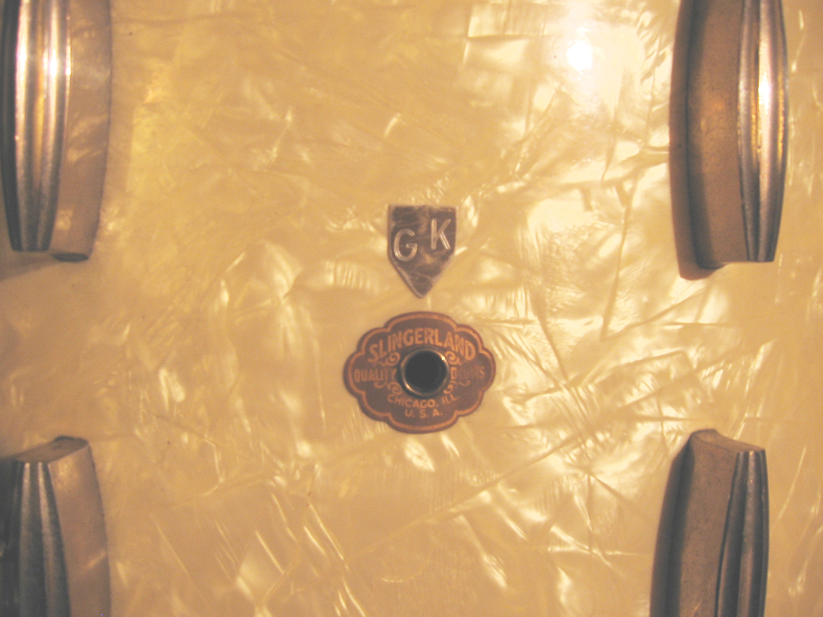 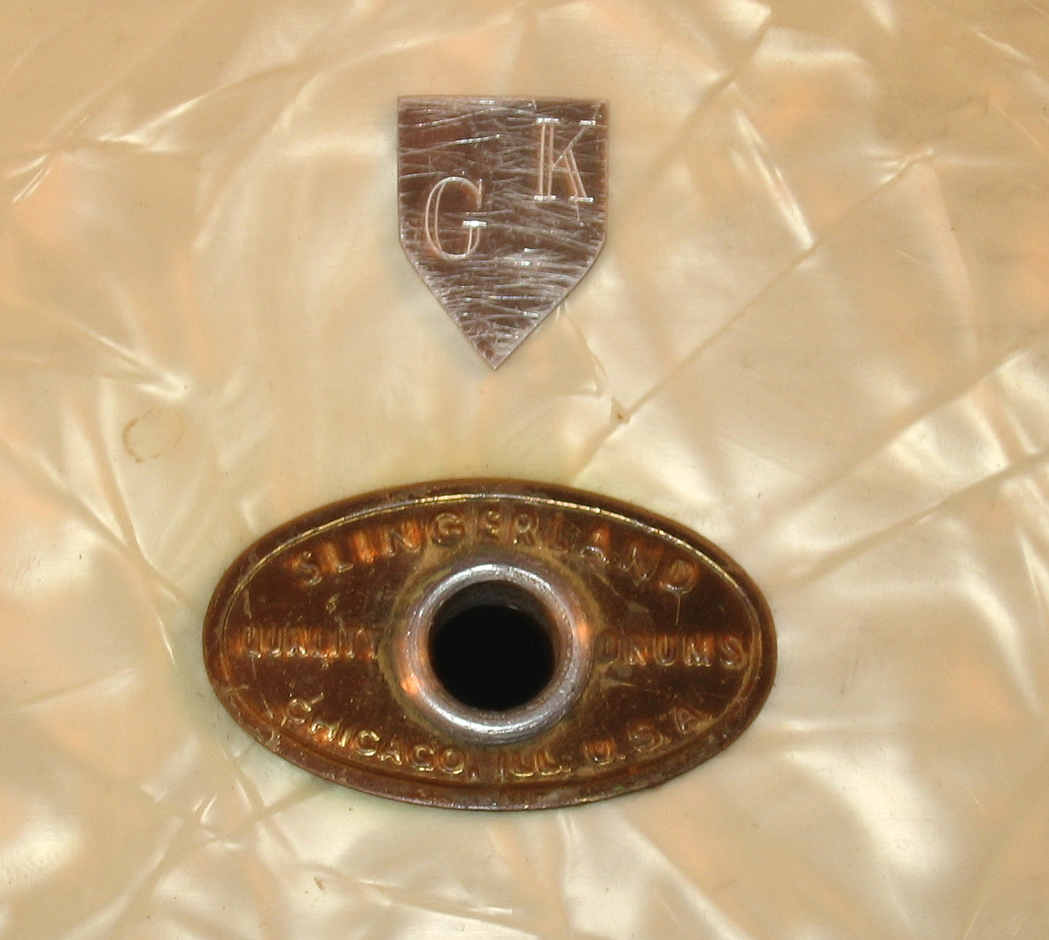 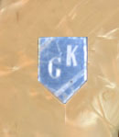
Above are images of those plates. All are actually aluminum base metal. Important to note that the two different Slingerland badges and the truly amateurish 'shaping' and obvious purposeful 'scuffing' of the shield plates were definite 'red flags' as well. Living and learning......
The three little bogus shields were, naturally, kept as a reminder of how easily fooled devoted collectors could be...
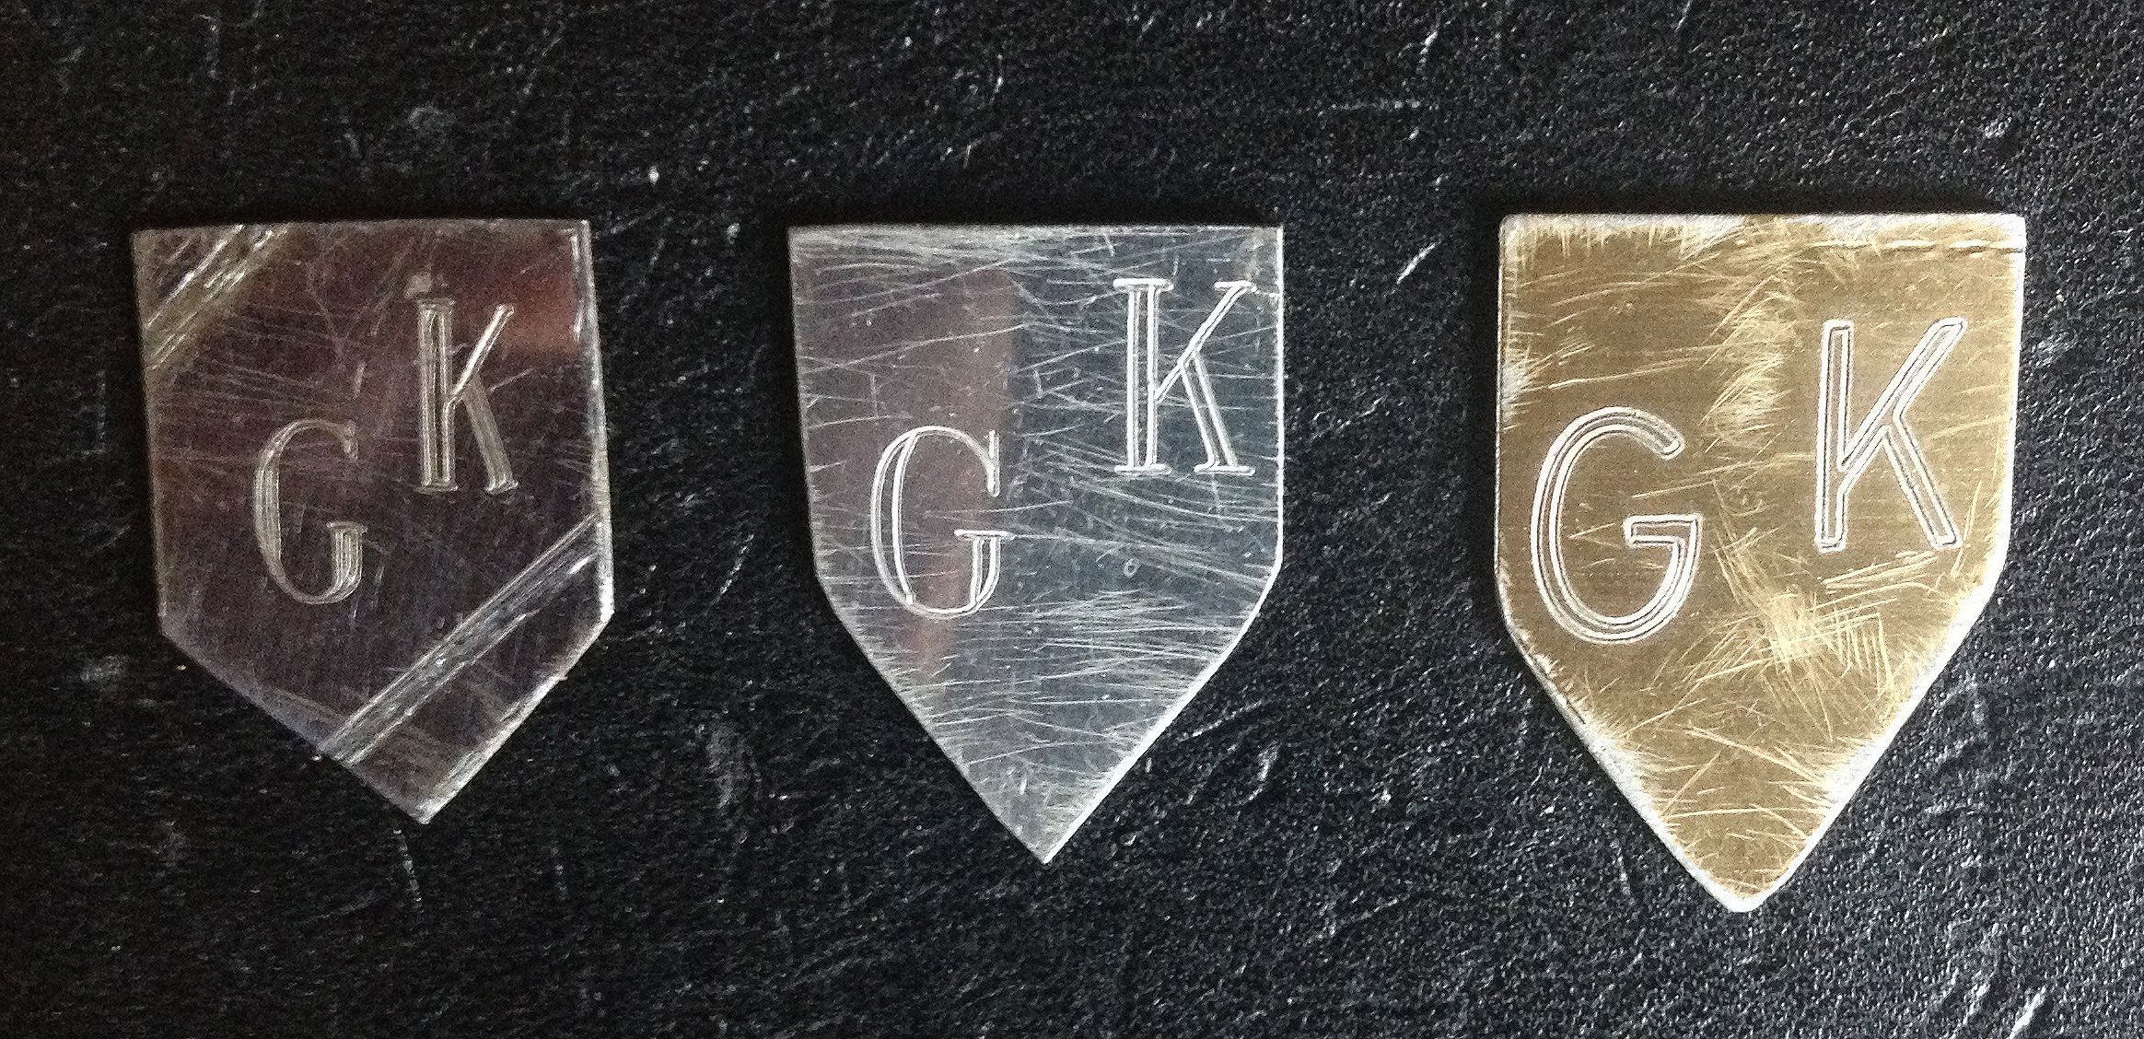
But the set itself went on to be put to good use for many years anyway.
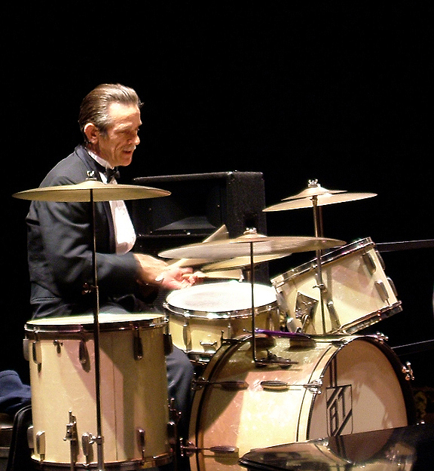
And the memories of a true, good friend who gave of himself to help out a zealous kid (with less knowledge than he should have had at the time)...
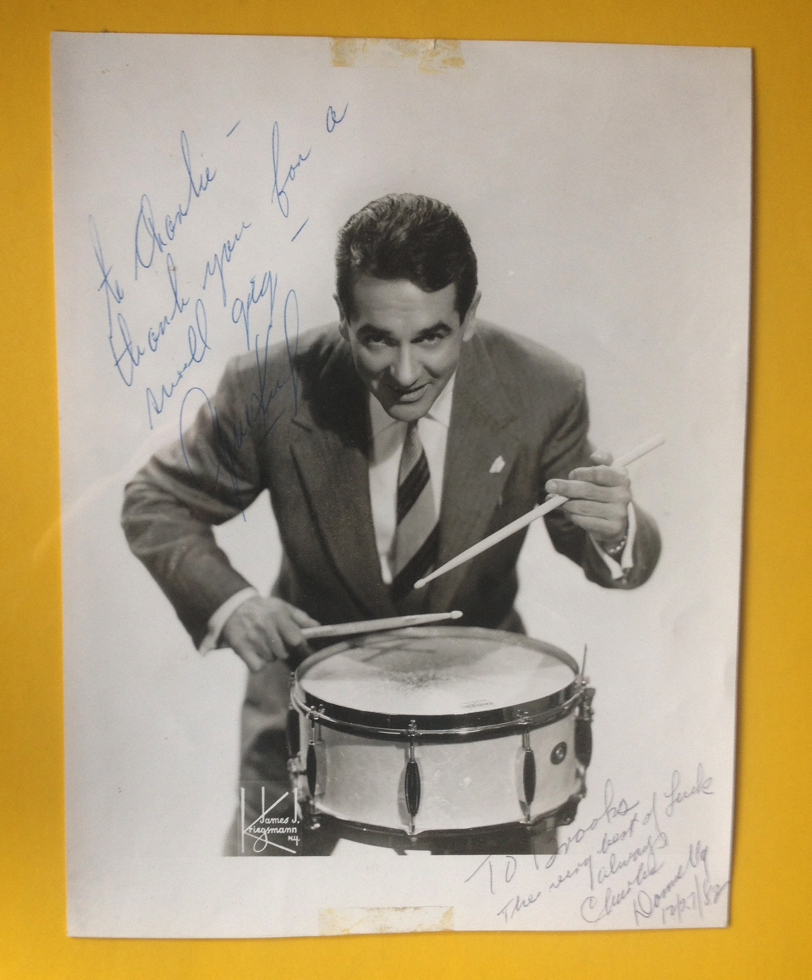
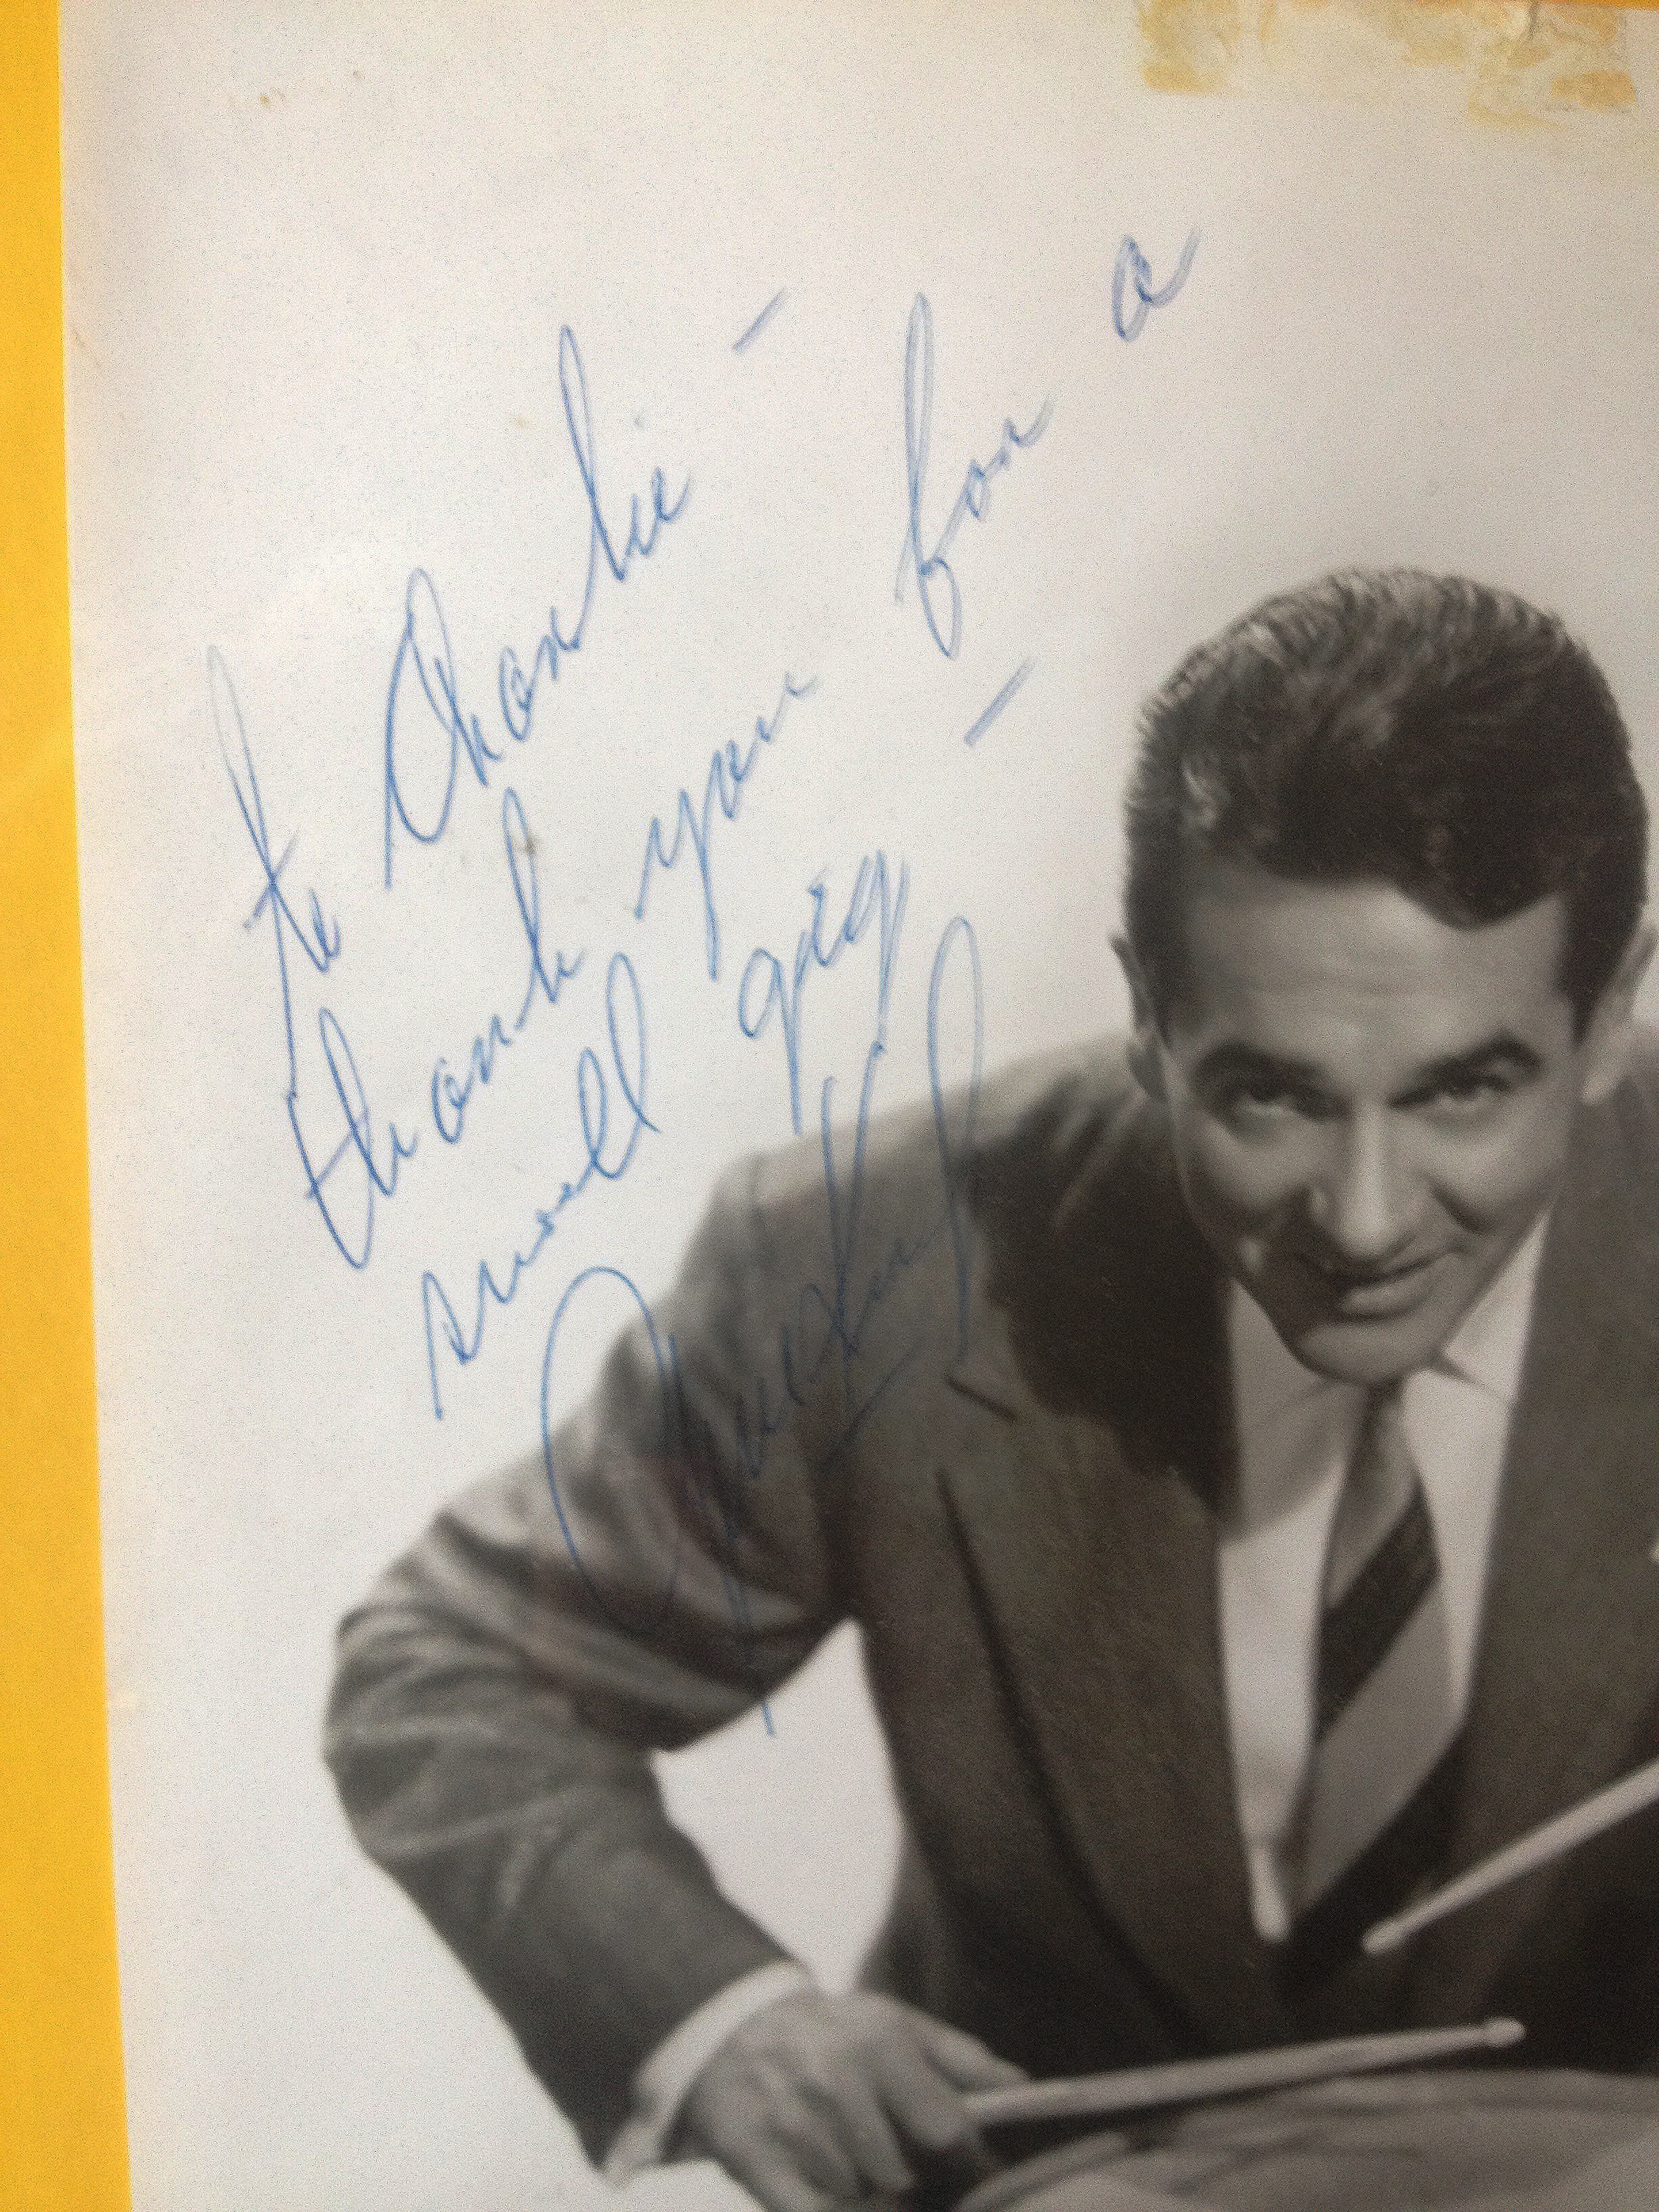 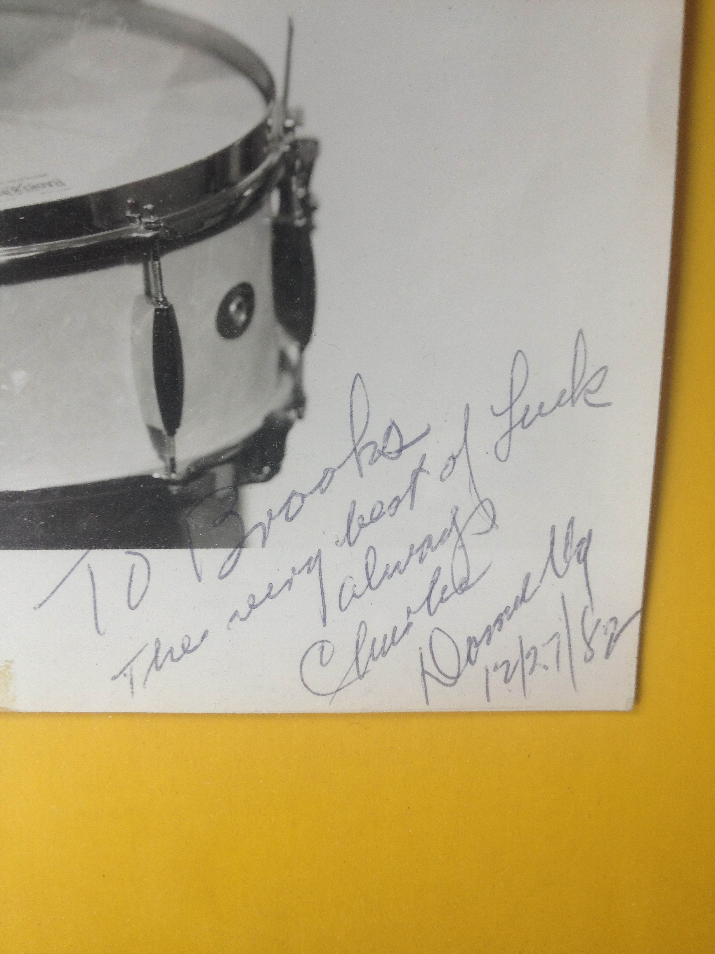
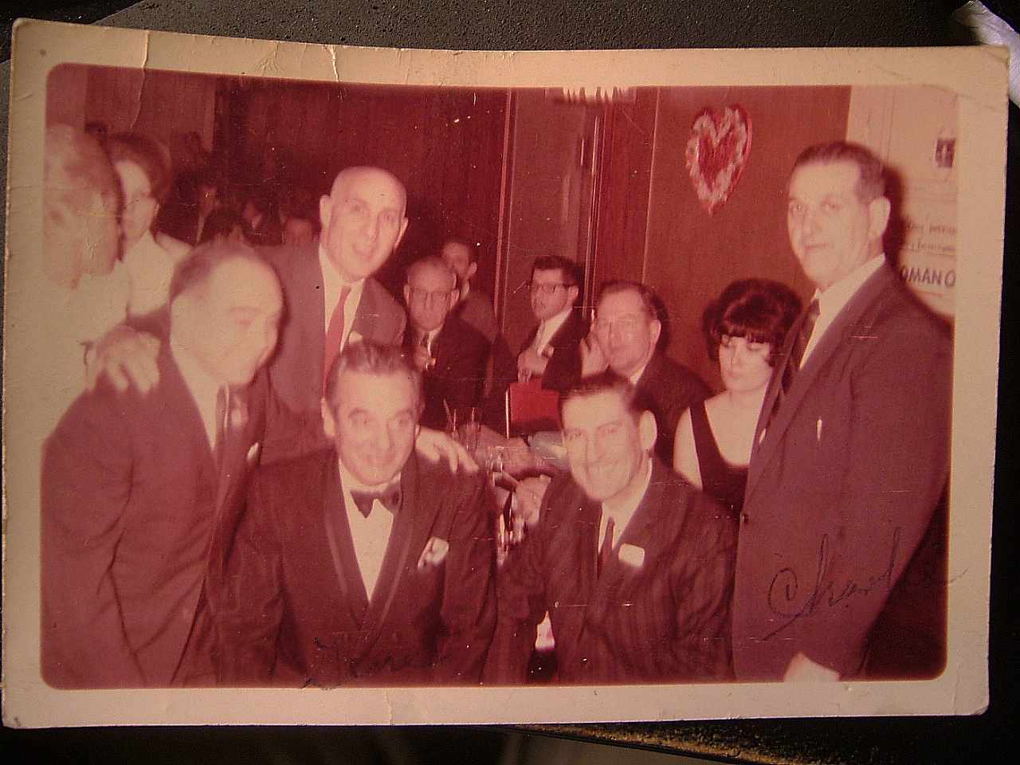 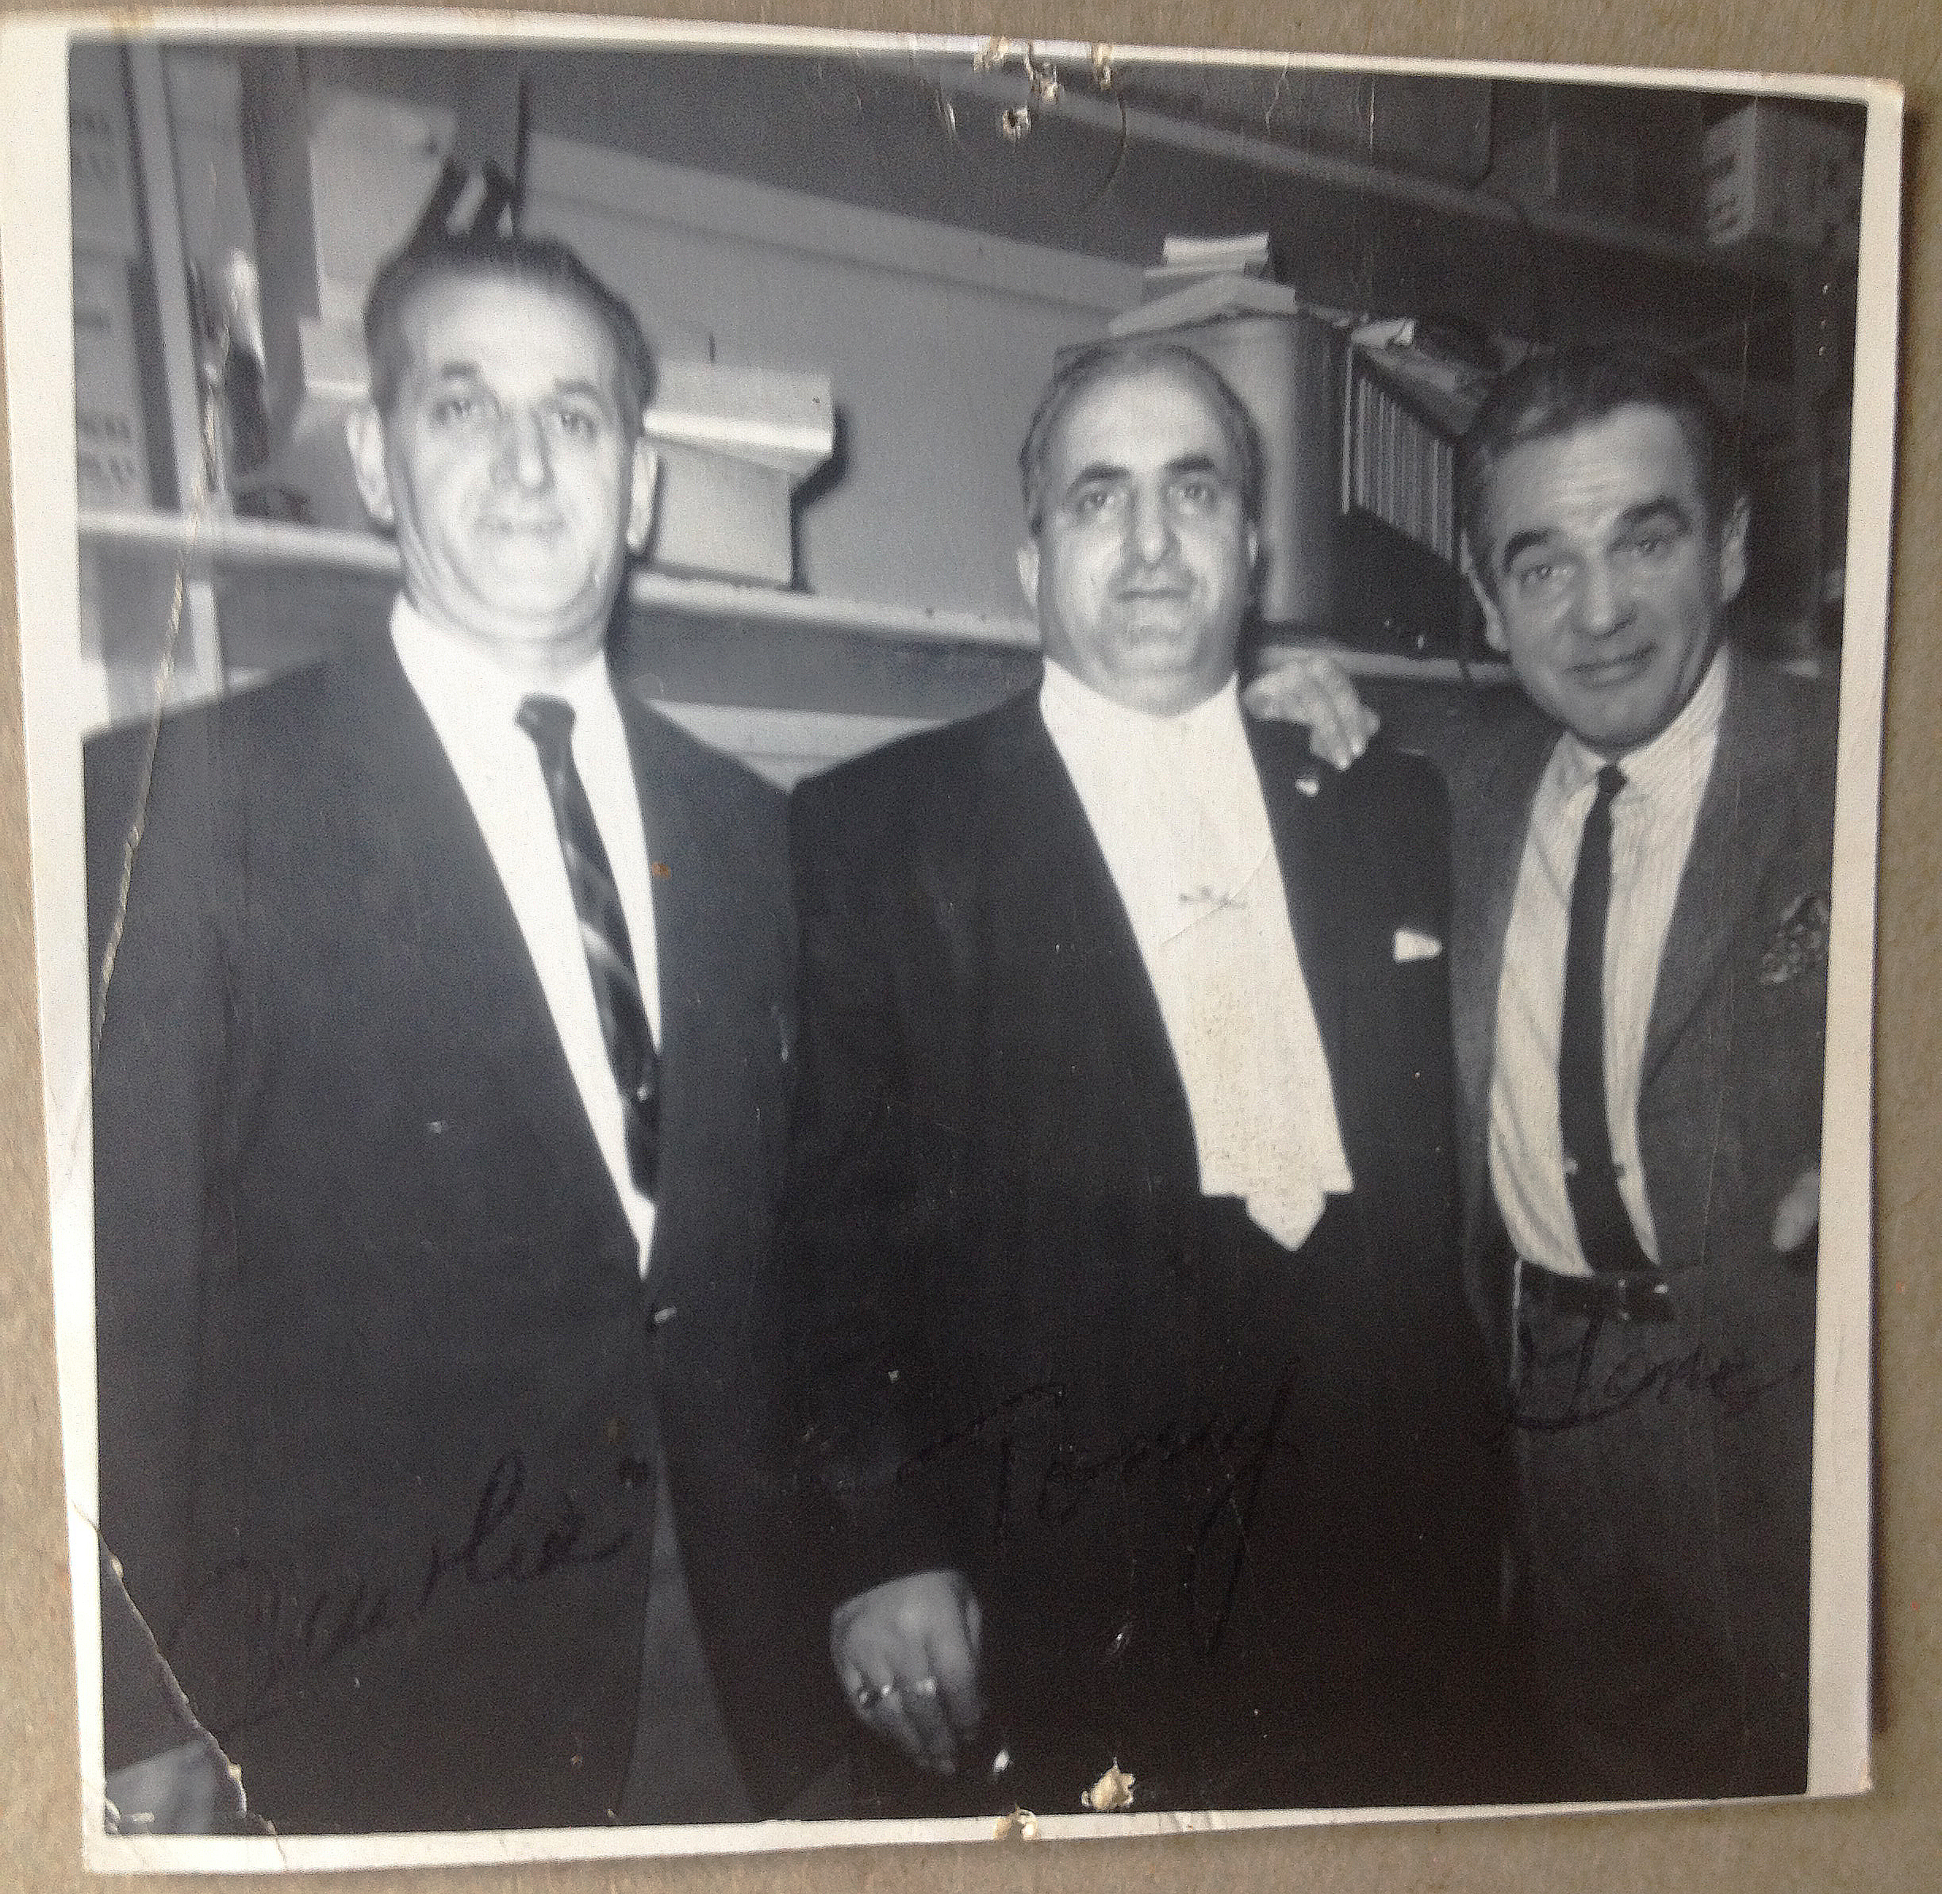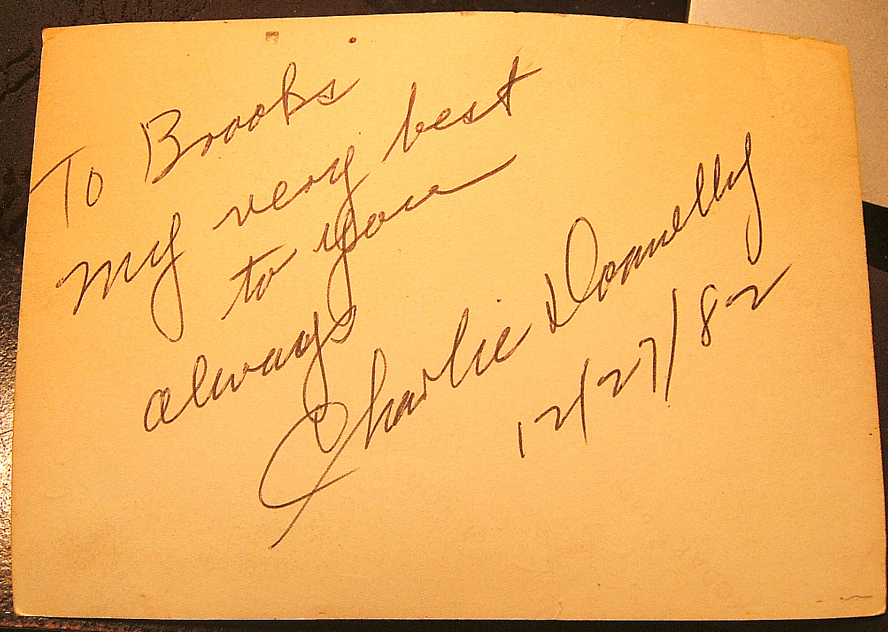 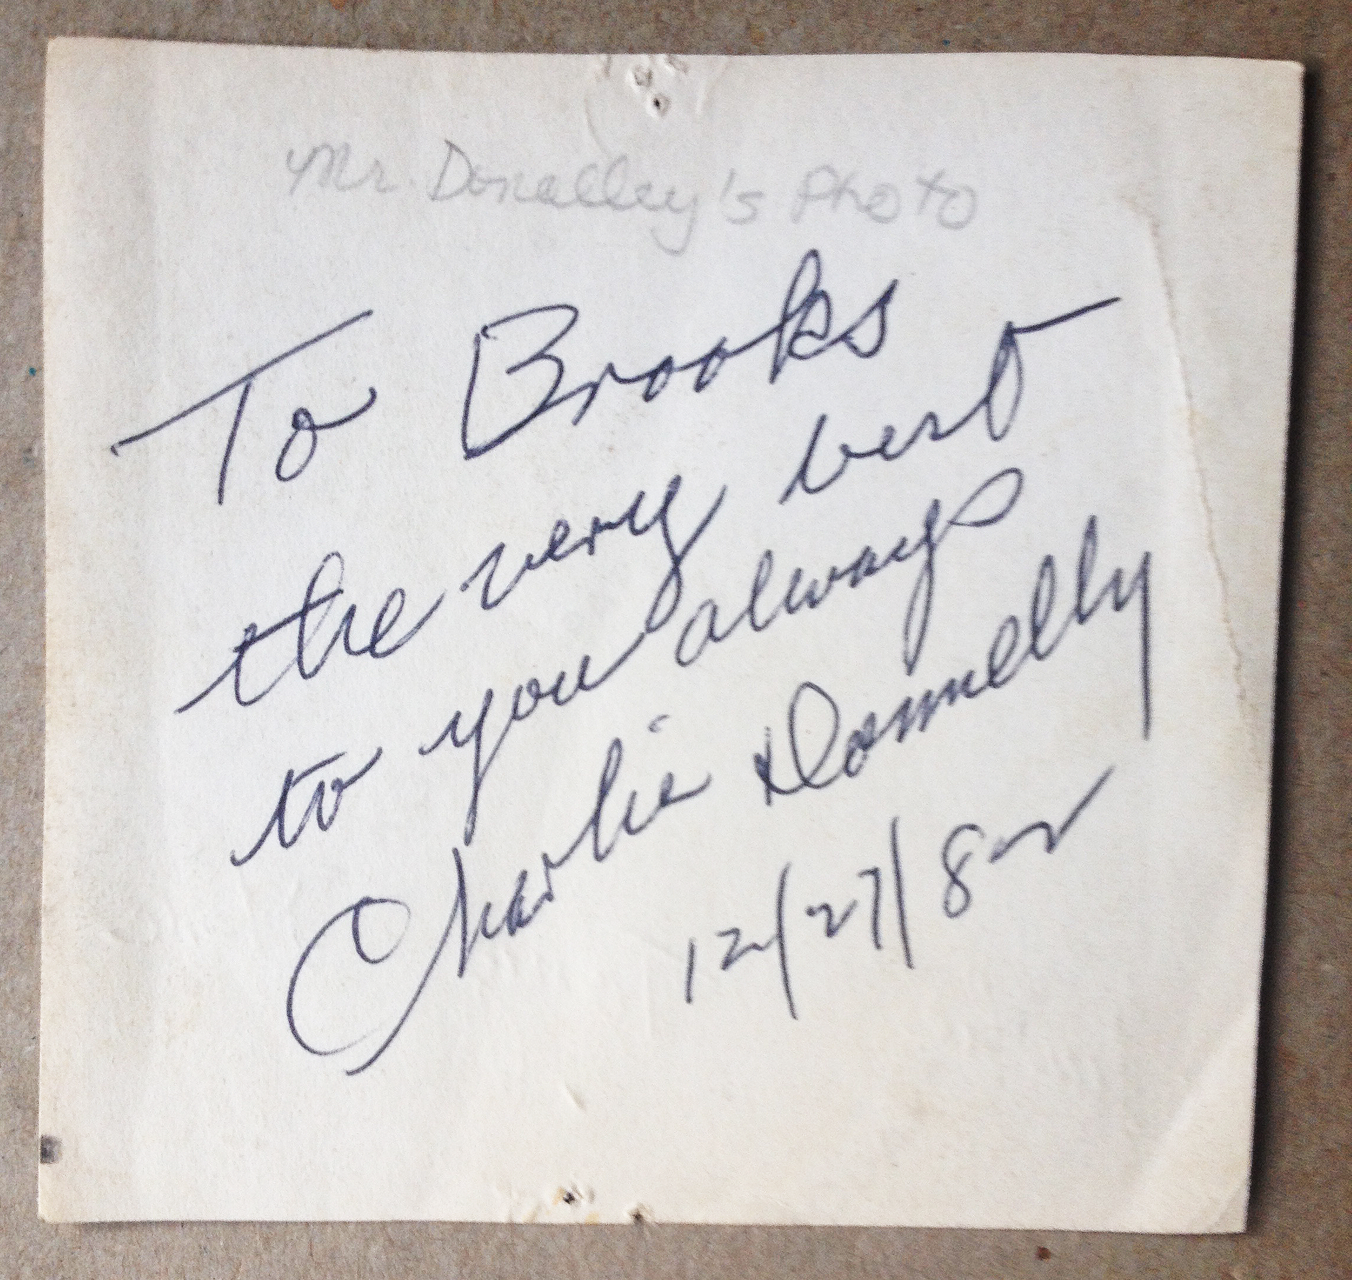
...has lasted long after the 'sting' of both being 'suckered in' has faded away... These photos and messages remain prized possessions of this author.
Then, of course, there was that set of cymbals....(yep. them too...). Acquired from a different source around the same time period but equally as fraudulent.
The grouping consisted of a 20 1/8 inch A Zildjian Ride, 18 inch A Zildjian crash and (only) the top cymbal of a 14 inch A Zildjian Hi- Hat cymbal set.
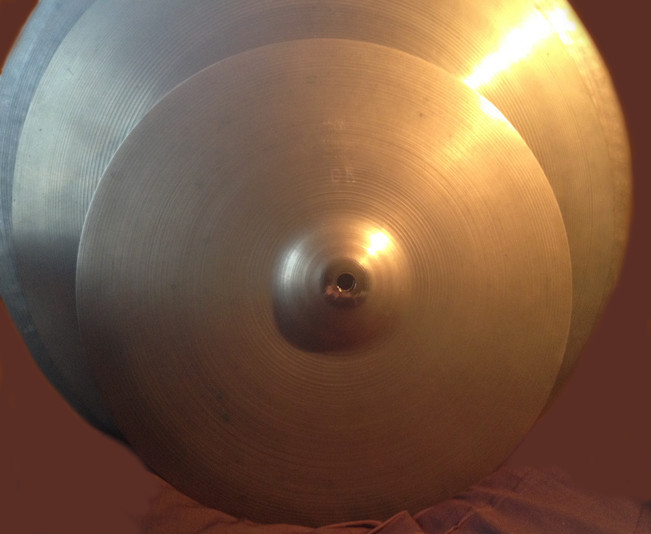 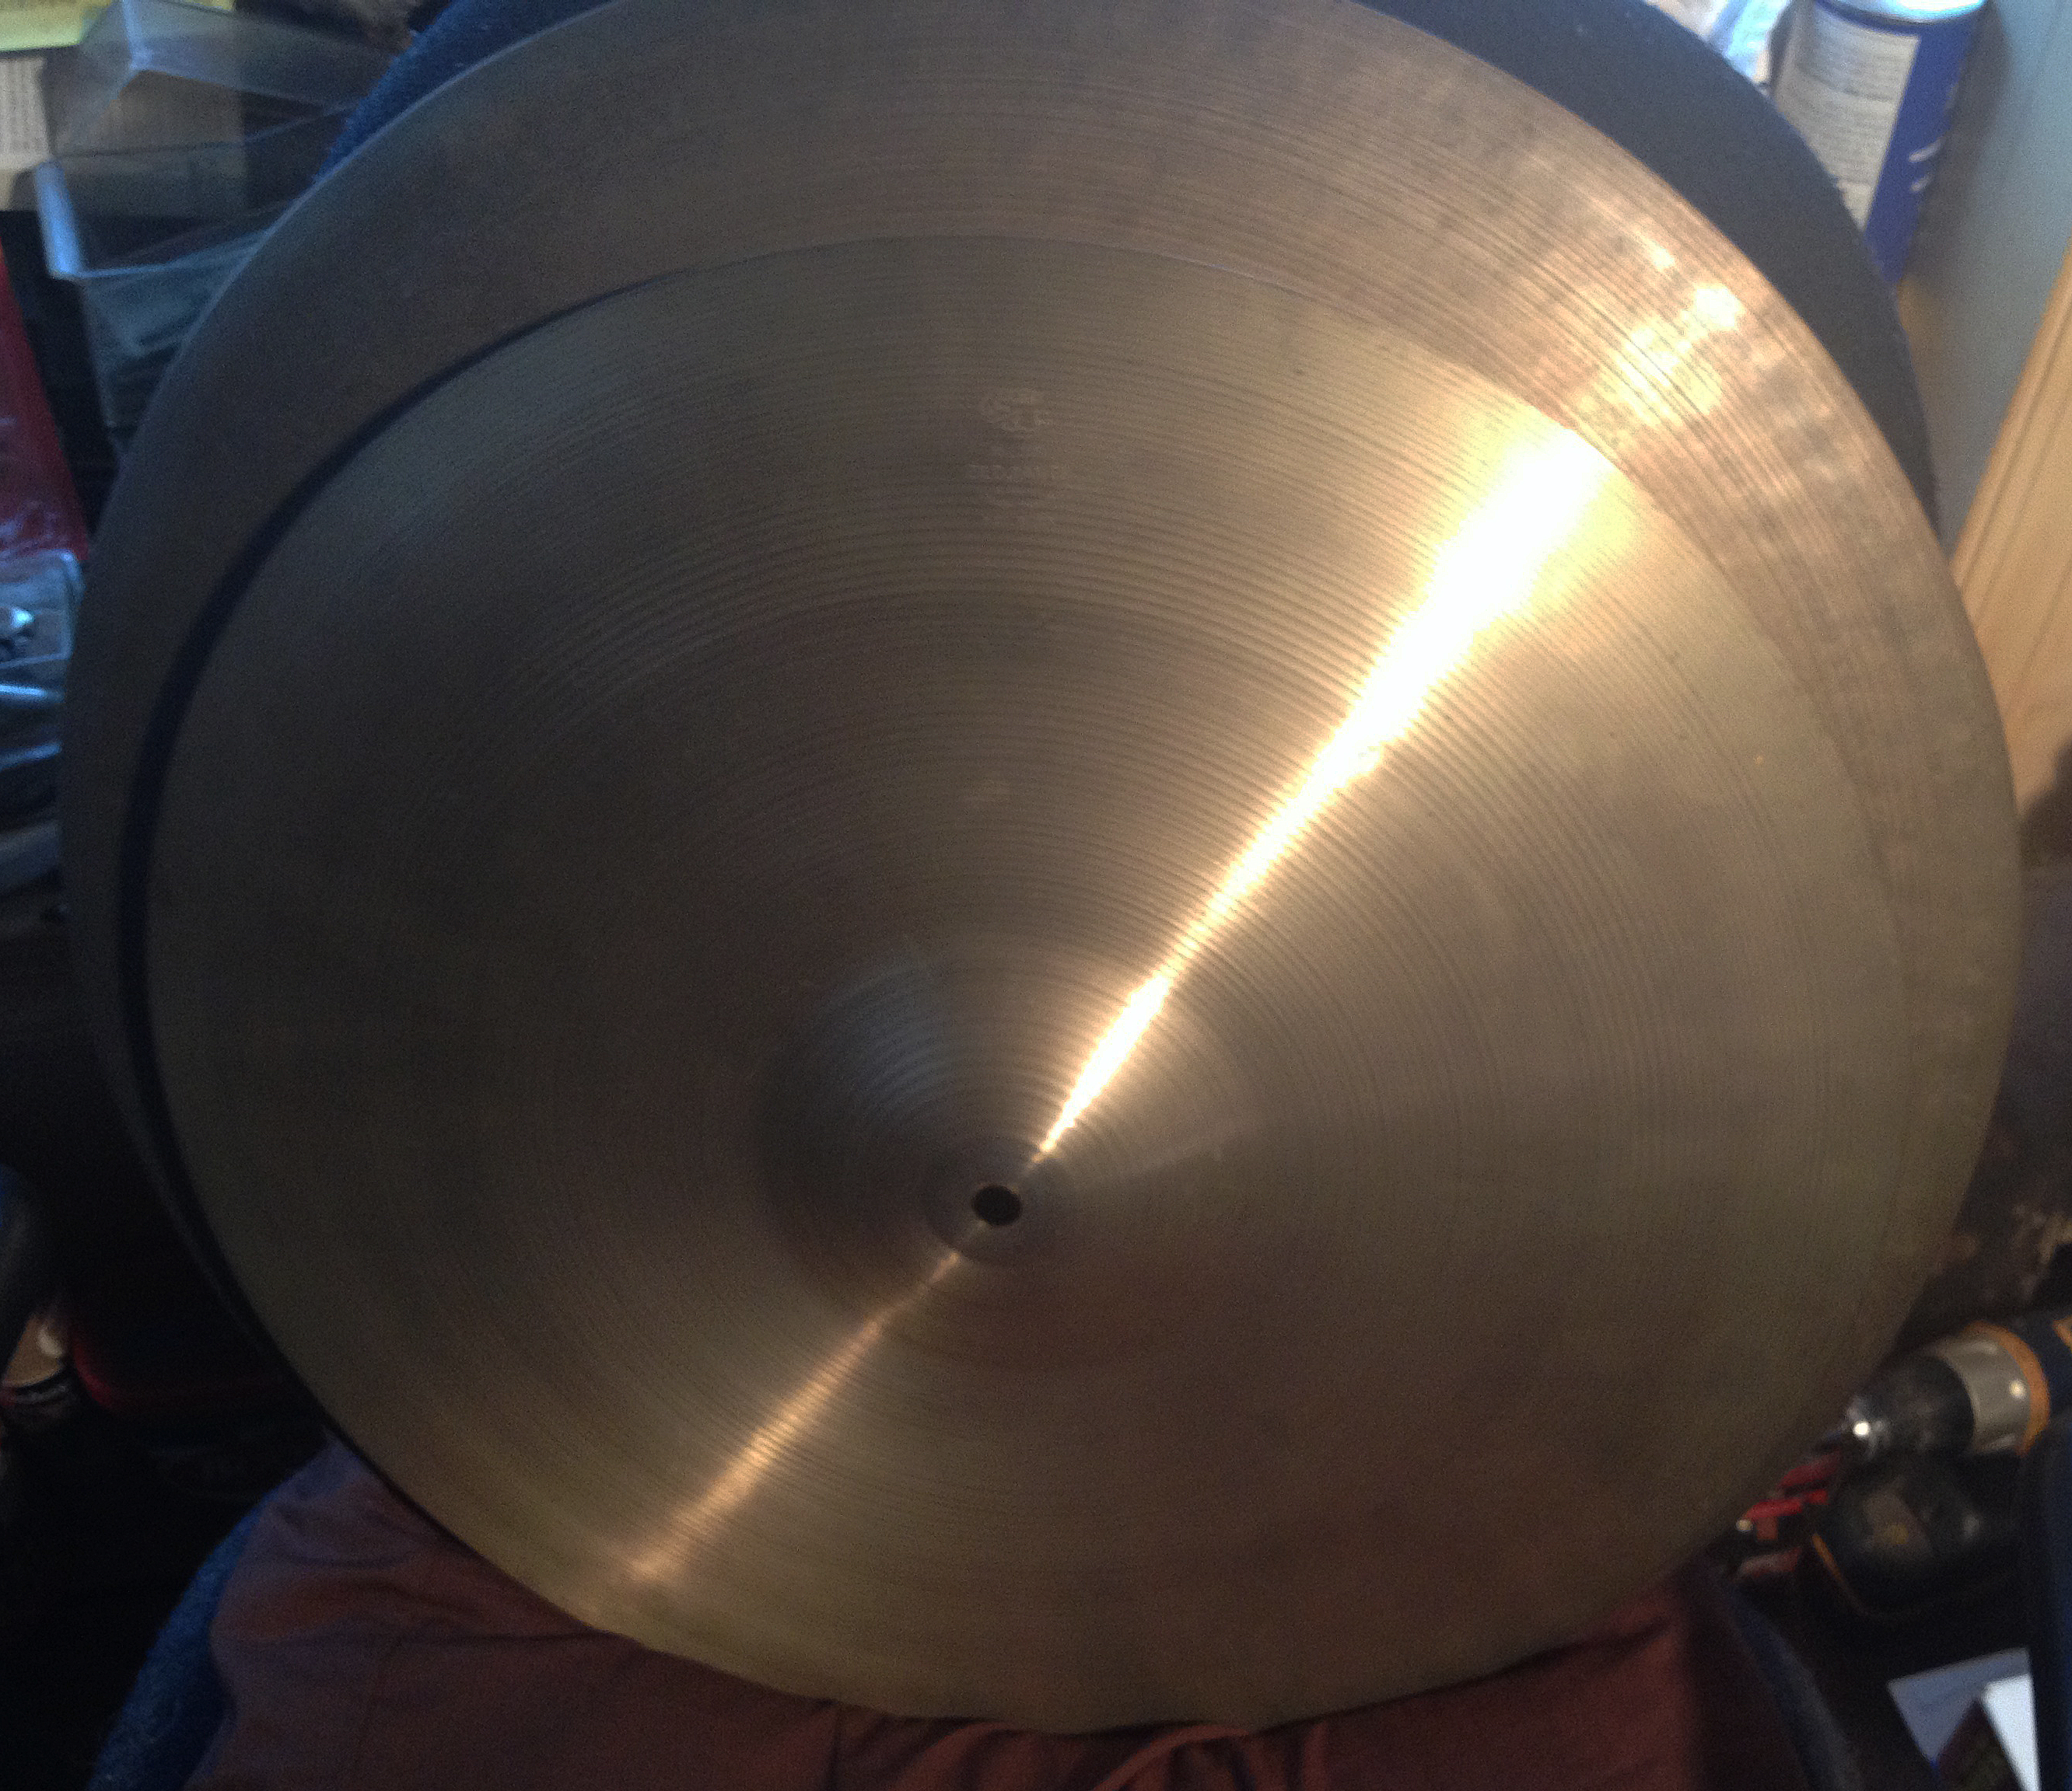
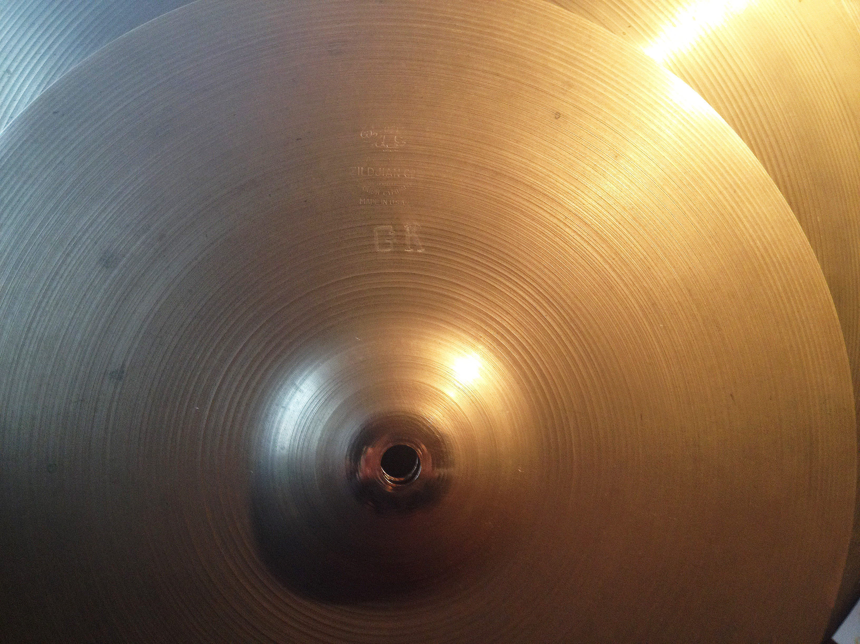 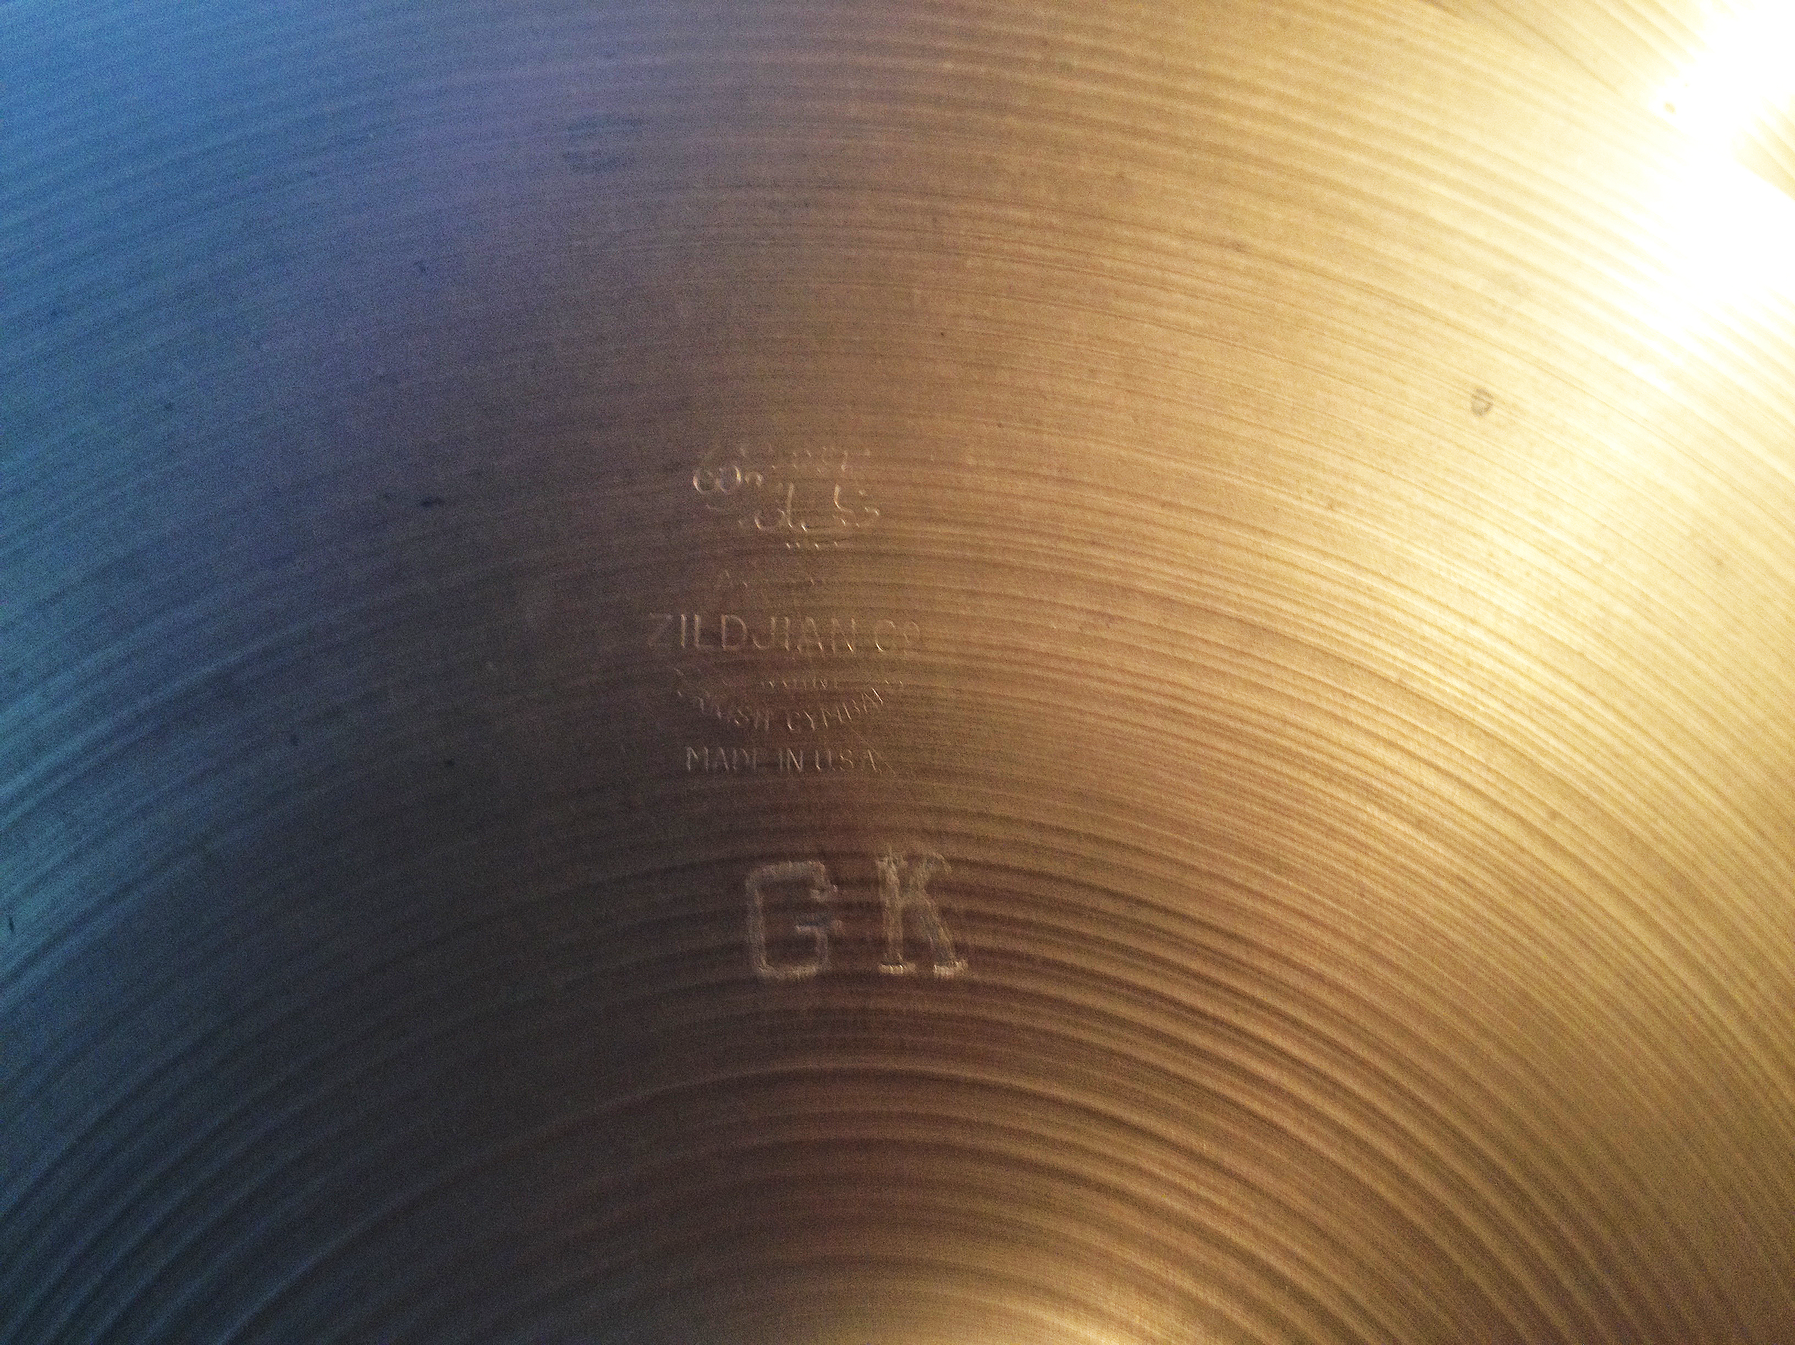
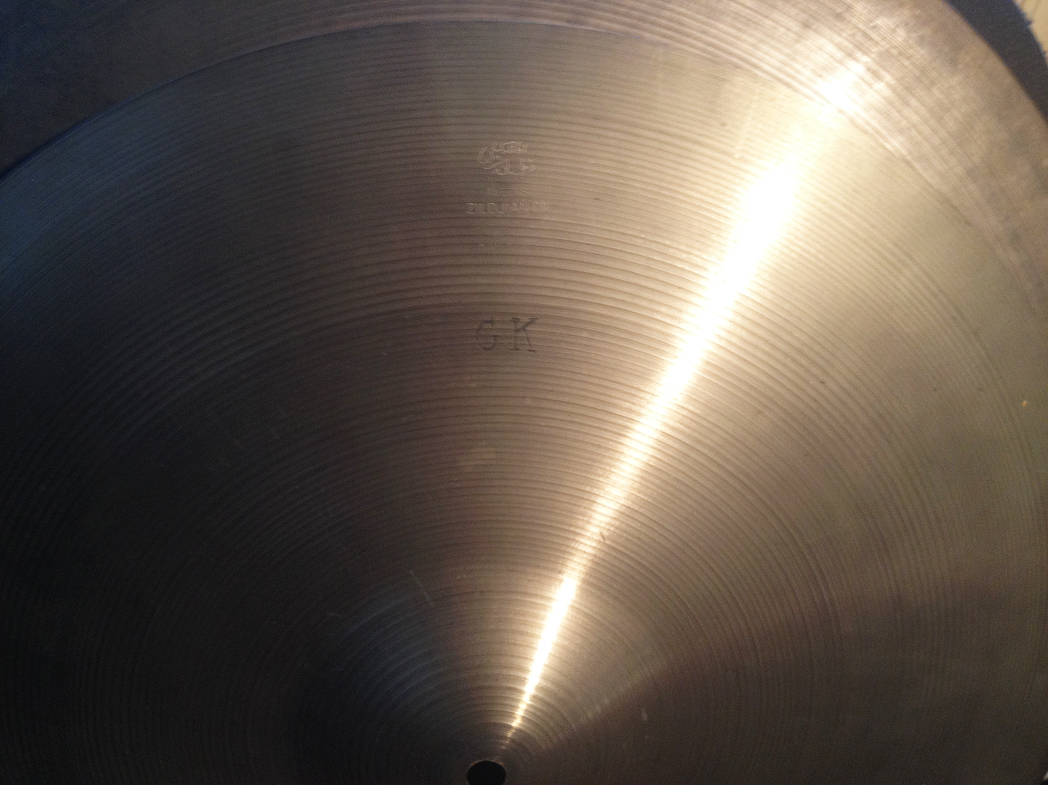 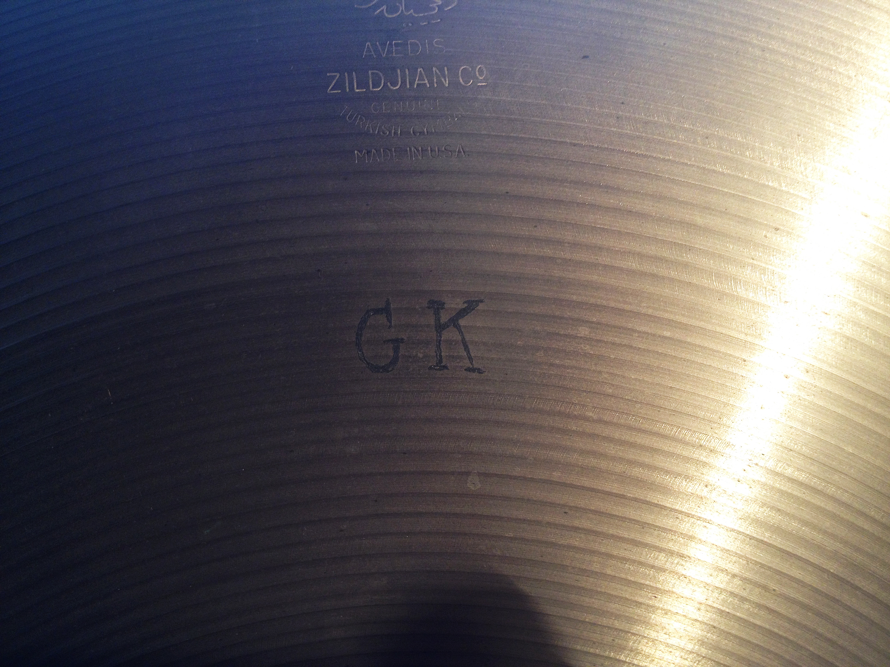
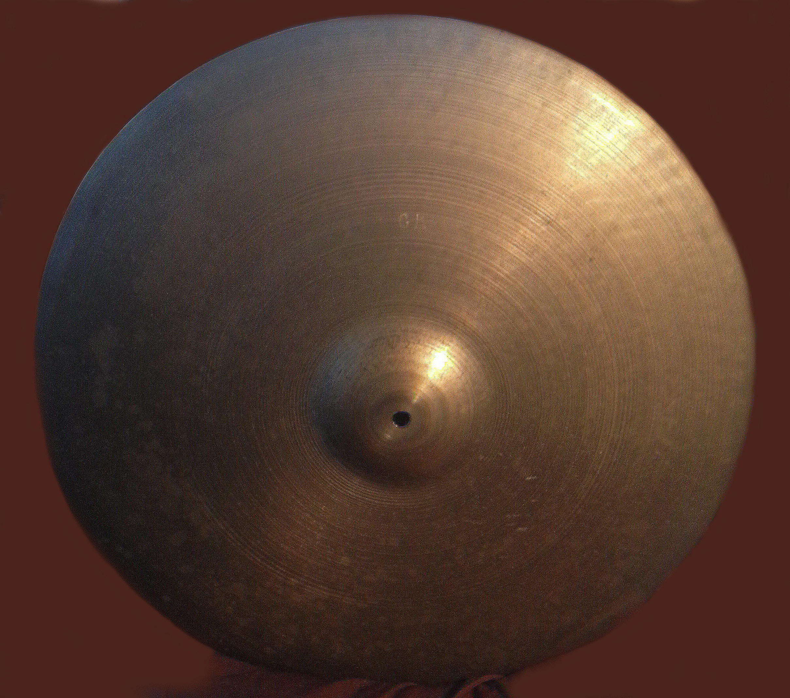 ..............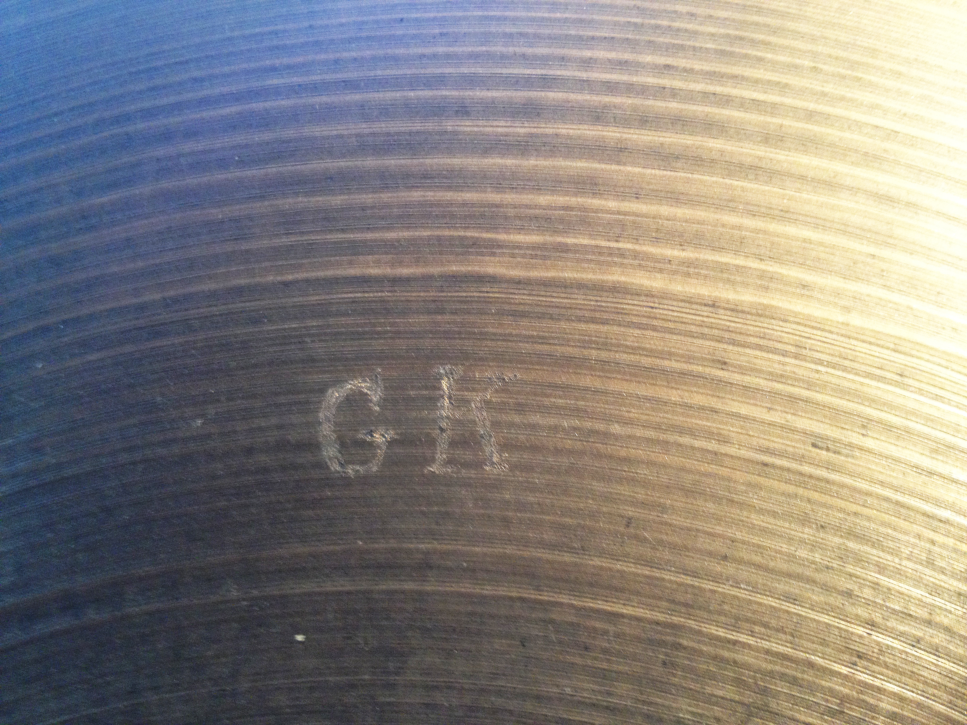
Obviously, whomever (originally) perpetrated this scam knew enough about the GK cymbal history to know sizes of a certain period of Gene's career as well as the need to add bogus initials to the cymbal set.
The biggest error was the fact that it was don with an electric engraver instead of the machine 'punch-stamp' letters that Zildjian used to mark all of Gene's cymbals with "GK". A valiant effort but a failure nonetheless.
Luckily, like the drums, they were actually very good A Zildjian cymbals and remain in use by the author to this day. Fabricating the bogus equipment in Gene's name is easily done because he was so reliably consistent in what he used for so long combined with the fact that few have even known the difference between real and phony.
Some have been lucky enough to get their hands on a "genuine article", assisted by their own knowledge and that of others. In most of these instances, there is a good amount of photographic 'evidence' to support the claims of authenticity. In a few instances, there has been "first-hand" contact with Gene or someone who was close to him that provides immediate provenance. In those cases, there is no doubt. When however, the next set of "hands" is found, it gradually moves farther away from safe fact and into the realm of suspicious doubt. In fact, one of the greatest stumbling blocks to researching this work. Few are even around anymore to have first-hand remembrances of the man himself and even fewer paid a great deal of attention to his equipment even up to the end. One would (wrongly) assume that people like Russ Connor and George Avakian would be well familiar with Gene's drums considering how often they saw (and possibly even moved) them. Not so, it turns out.

